()



z

-mI

# z

�

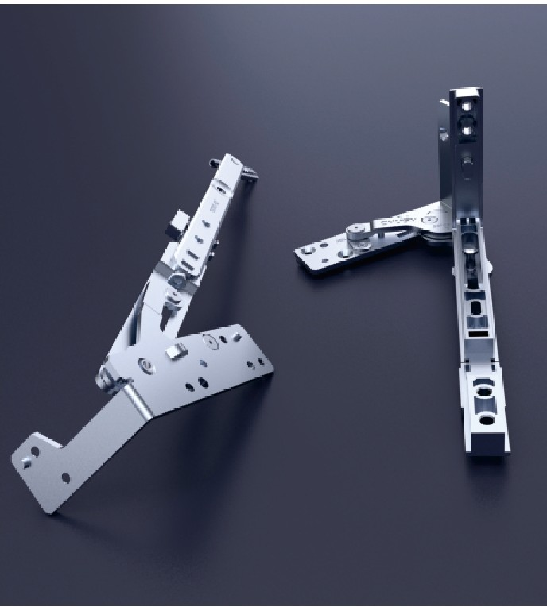

001-004 / The Tilt And Turn Hardware System 005-008/ Casement Window Hardware Series 009-012 / Casement Door Hardware Series

013-014 / Sliding Window&Doors Hardware Series

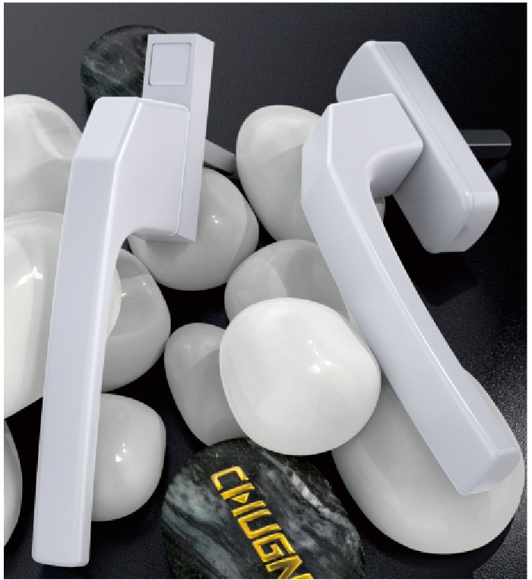

015-025 / Transmission Handle Series 026-030 / Transmitter Series

031-032 / Keeper Series

033-034 / Door Handle Series

03 7-038/ Lock Plate& Cylinder Series

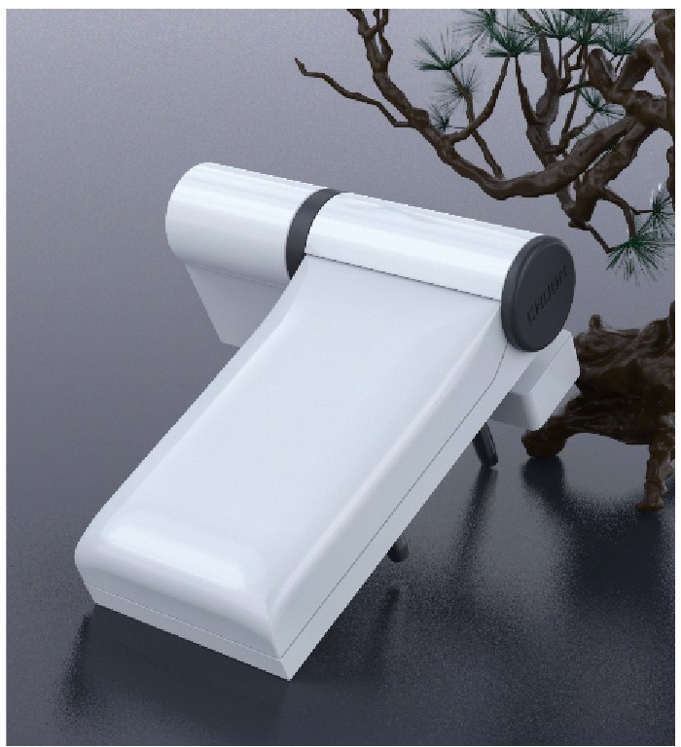

039-044/ Hinge Series

045-046 / Casement Fastener Handle Series 046-050/ Sliding Series

051-056/ Roller Series

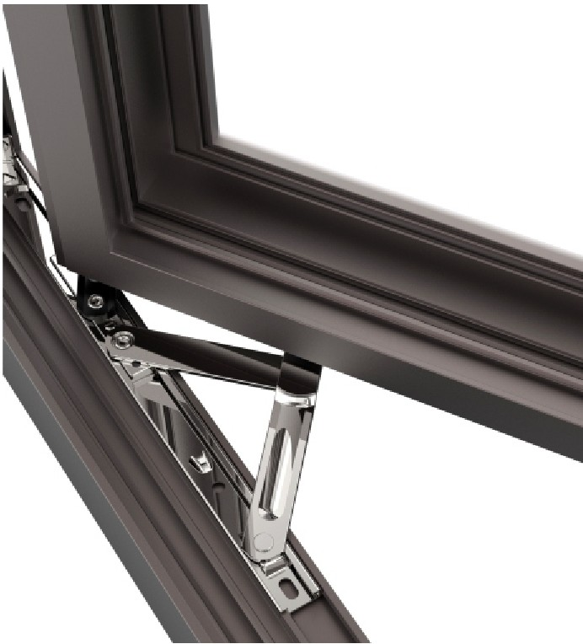

05 7 / Sliding Door Handle Series 058 / Friction Hinge Series

059 / Bolt Series

060 / Stay Arm Series

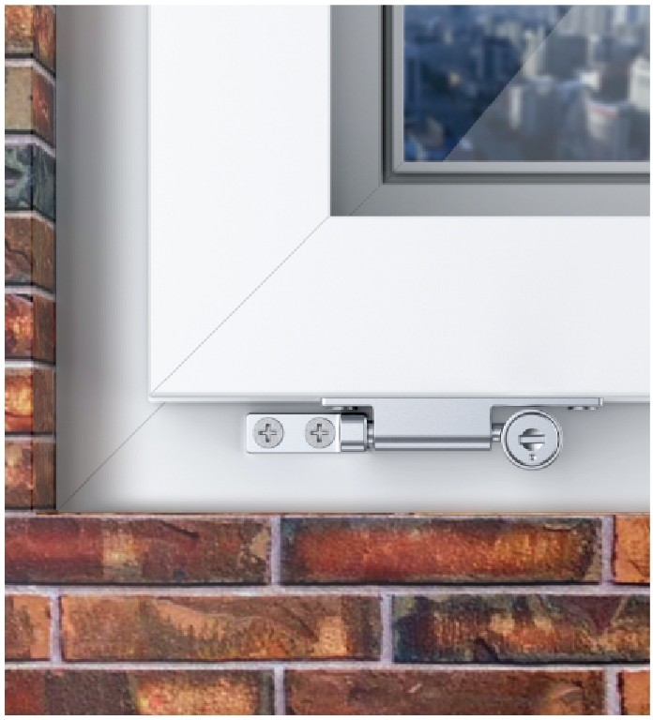

061-063 / Accessories Series



'

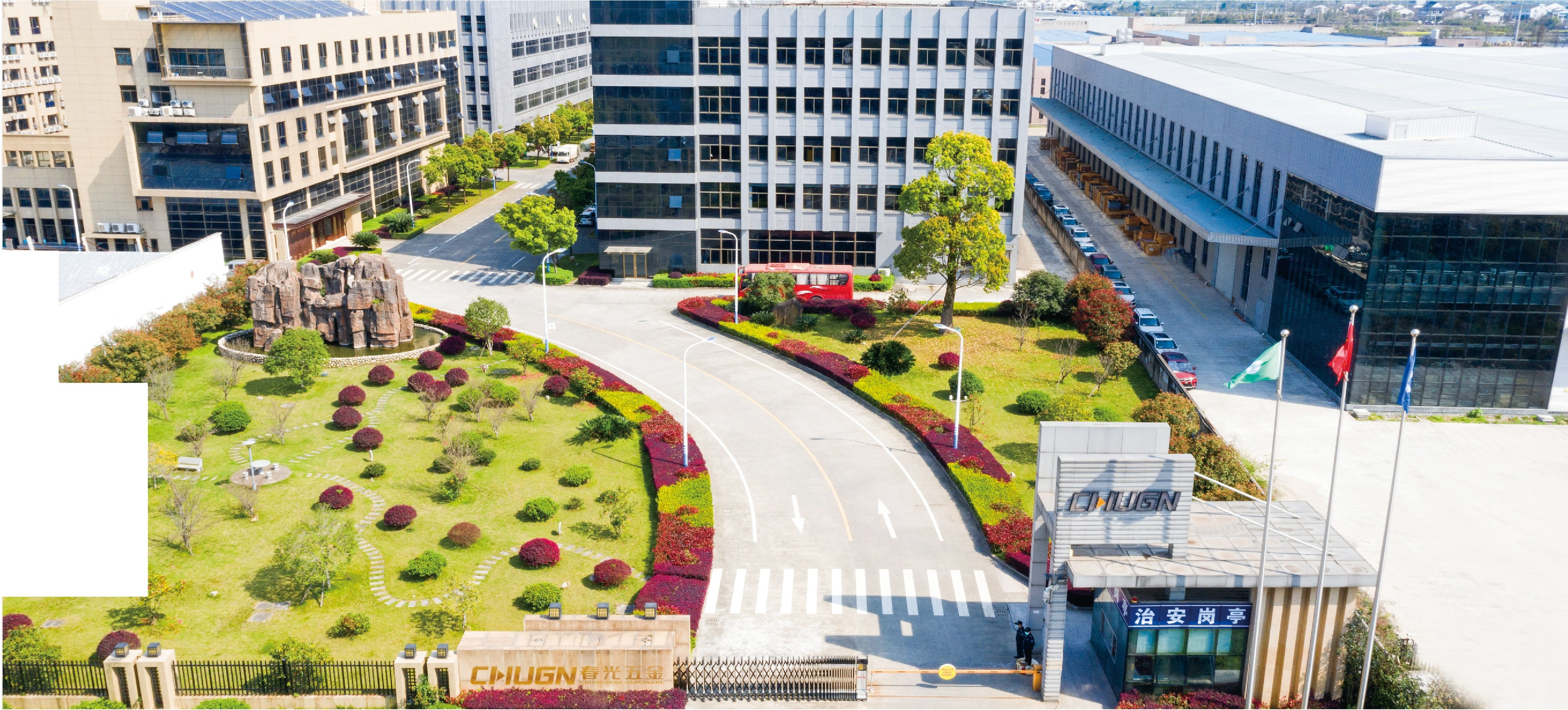

**COMPANY**

**PROFILE**

Founded in 1994,chunguang hardware is the hardware accessoriessupplier with international reputation. we focus on designing and producing hardware accessories for wooden, aluminum and wooden composite doors and windows

,for thermal insulation doors and windows, curtain walls ,and pvc doors and windows.

Our headquarters located in wenzhou city. we are one of the largest leading manufactures for hardware accessories of doors and windows in domestic. our sales network throughout the country, we have established a stable market in europe ,america ,middle east, africa and southeast asia.

We have a high-quality technical management team and production management team.we focus on develop new products and technical innovation and participate in making industry standard formulation. we have 90 various patents .we took the lead through the kcpc certification,1SO9001 international quality system certification ,1SO14001 environmental management system certification and OHSAS18001 certificate of conformity of occupational health and safety management system.

More than 20 years' market practice and innovation,chunguang has become a well-known brand for hardware fittings of pvc and aluminium doors and windows. excellent enterprise culture, advanced design high quality and perfect service system lay chunguang as the leading enterprise position .we got widely recognized by consumers and society ,also won the approval by the authoritative department.

Improve the technology and quality embodies the value of the company, at the same time is a social responsibility. chunguang will adhere to the enterprise culture essence of" practical-minded, technological innovation, we will meet opportunities and challenges for international strategy with a positive open attitude.we will continue to focus on the development and innovation of the doors and windows accessories.adhere to the products position of "the exclusive, perfect products,

top quality", we will take where has high quality door and windows ,where has chunguang hardware"as our duty, leading domestic and international doors and windows hardware fittings develop individualization and intelligence.

**HISTORY**

**2005**

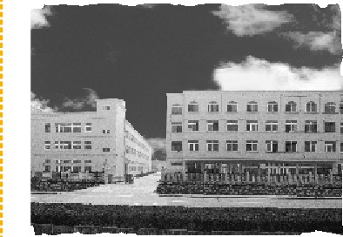

**2014**

**2016 2020**

**1998**

With the emergence of PVC profile and PVC doors and windows in China, we decided to invest in the R&D of hardware accessories for PVC doors and windows, and put into production in 2000.

**2003**

Wenzhou ChunGuang hardware CO.,LTD Was established, registered" CHUGN" brand and founded our name brand.

Expand production scale for the accessories of the thermal insulation doors and windows and curtain wall, and expand export scale, our products exported to Europe, America,

Middle East, Africa and Southeast Asia countries.

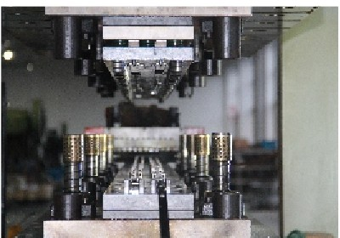

The headquarter office building and large standard factory area of Chunguang company have been built and put into use. It has become one of the largest hardware manufacturers of aluminum alloy doors and windows, PVC doors and windows, wooden doors and windows and home decoration in China.

**2015**

We launched the global advanced ERP management system, set up branch offices and sales networks for overseas and build global sales channels and Internet technology platforms.New mission of ChunGuang company: where there is top quality door and window, there is ChunGuang hardware, creating a safe and happy home for users.

**2017**

ChunGuang has become partners of aircraft carrier strategic with real estate of 100 billion .Enter the field

of intelligent door and window hardware, and strive to realize the mission for navigator of the global intelligent hardware of door and window

- - -

**2021**

**2008 2012**

ChunGuang are the first enterprise that

In response to "Made in China 2025", the company has invested in R&D and intelligent manufacturing to accelerate the transformation and upgrading for intelligent products.

With the advent of refined decoration and complete decoration in real estate industry, ChunGuang has increased efforts to invest in the R&D of home decoration products to meet the needs of China's real estate market. In the same year, the company passed

ISO14001 environmental management system

In the future......

**1994 2002**

We Invested 30 million yuan to establish Jiangxi branch production

base in Yujiang county, Jiangxi province.

The headquarter of ChunGuang was built and put into usein Pingyang factory area, ChunGuang mission: "where there is door and window in the world, there is ChunGuang hardware"

passed the KCPC, and successfully entered the procurement information platform of the construction materials department of the security housing

It has been approved to be the

and OHSASlS00l:2007 occupational health and safety management system certification.

Ruian ChunGuang hardware lock factory was set up, mainly produce common aluminum accessories of doors and windows .At the beginning.we determined our grand development goal for becoming a leading enterprise in the construction hardware industry of door and window

ChunGuang has gradually expanded its development scale and passed 1SO9001 international quality system certification.With the growth of export business volume, we set up our export department, our products exported to Western Europe, Eastern Europe, southeast Asia countries.

designated enterprise of building doors and Windows fittings and in the same year, start the strategic cooperation with China real estate

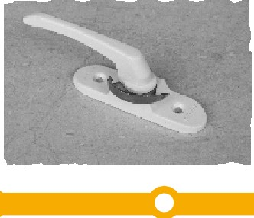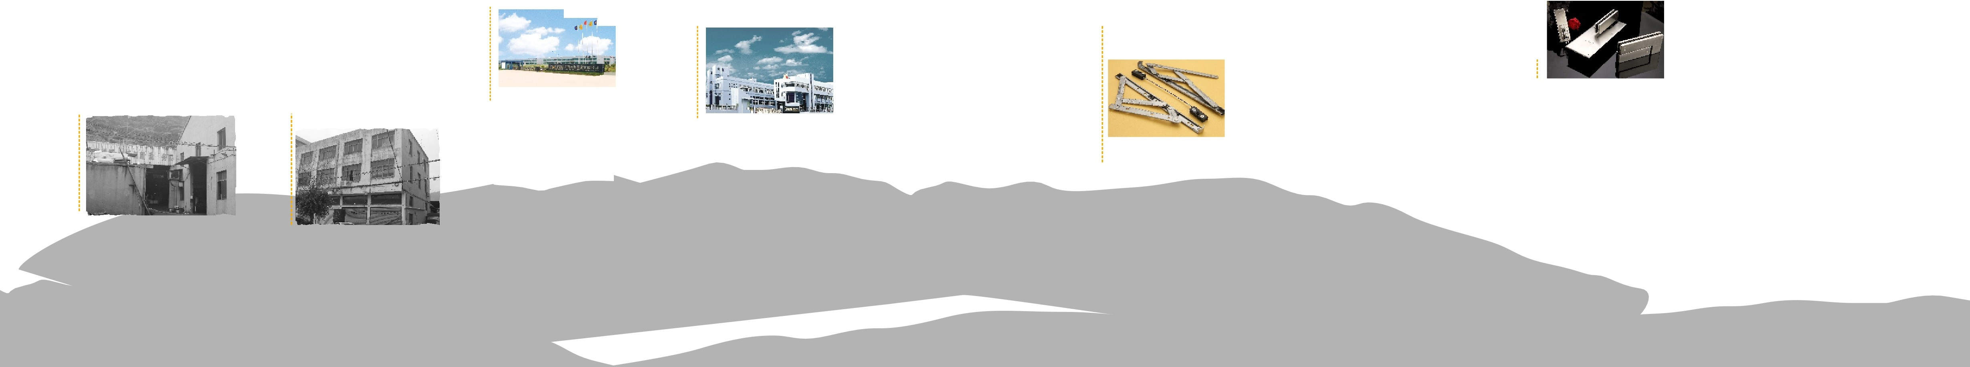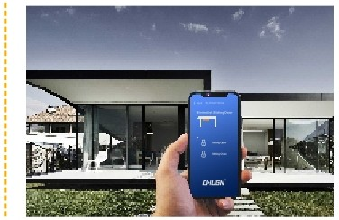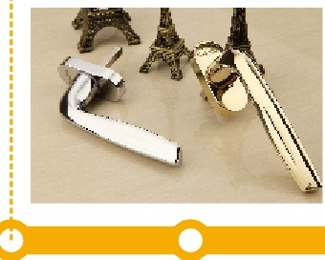

  

#### SGSX102 THE TILT AND TURN HARDWARE SYSTEM FOR U-PVC(9/13)

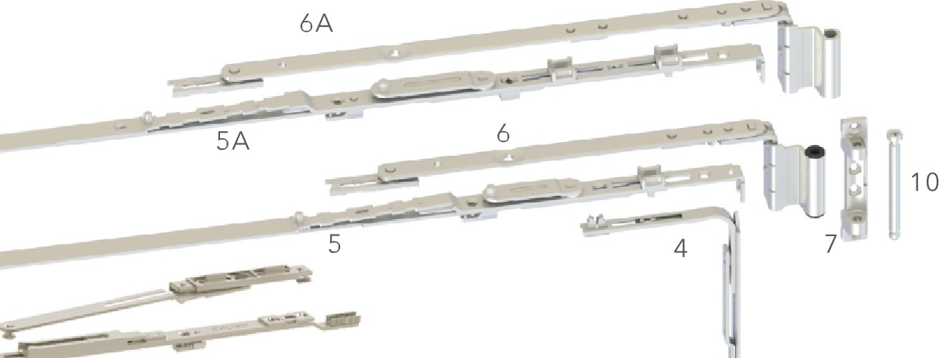

17

13

|  |  |  |  |  |
| --- | --- | --- | --- | --- |
| NO. | NAME | ITEM NO. | NUMBER | NOTE |
| 1 | CORNER DEVICE | CGZXJ01 | 1 |  |
| 1A | CORNER DEVICE | CGZXJ01A | 1 | optional |
| 2 | OVERTURN SUPPORTER | CGFZ0S | 1 |  |
| 3 | TRANSMITTER | CGCDG75C | 1 |  |
| 4 | CORNER DEVICE | CGZJS01 | 1 |  |
| 5 | SASH STAY GUIDE | CGDXG250 | 1 |  |
| SA | SASH STAY GUIDE | CGDXG350 | 1 | optional |
| 6 | CONNECTOR ROD | CGXLG250 | 1 |  |
| 6A | CONNECTOR ROD | CGXLG350 | 1 | optional |
| 7 | UPPER PIVOT HINGE | CGJL020SB-01-04 | 1 |  |
| 8 | BOTTOM PIVOT HINGE | CGJL020SB-02G) | 1 |  |
| 9 | BOTTOM PIVOT HINGE | CGJL020SB-02(2) | 1 |  |
| 10 | THE UPPER HINGE PIN | CGJL020SB-01-09 | 1 |  |
| 11 | ANTI-MISOPERATION BLOCK | CGFWQ01 | 1 |  |
| 12 | LIFTING BASE | CGTQ01 | 1 |  |
| 13 | KEEPER | CGK015/CGK016 | 2-3 | optional |
| 14 | SUPPORTING BLOCK | CGFZ0S-01 | 1 |  |
| 15 | ANTI-FALL BLOCK | CGFZ0S-02 | 1 |  |
| 16 | HANDLE | CGZS003-CD | 1 | optional |
| 17 | ADDITIONAL TILT AND TURN ARM | CGFLG01 | 1 | separately to buy |

13

##### INSTRUCTION

1.CGZXJ01 A suit for sash width between 330-430mm. 2.CGDXG250&CGXLG250 suit for sash width between 431-630mm. 3.CGDXG350&CGXLG350 suit for sash width between 631-830mm.

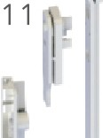4. You need to install when the window sash width is greater than 830mm.

16 5.Capacity 90Kg,suggested proportion of window width/window height at 1:1.5.

##### TECHNICAL PARAMETERS

12 TRANSMITTER

\ /;

*/1*

\; I

,,, ,,, \ *I*

II

*'{*

I '

*I* ,, ,,-

\

|  |  |
| --- | --- |
| MODEL | SASH HEIGHT RANGE |
| 800mm | 685-1110mm |
| 1000mm | 885-1310mm |
| 1200mm | 1085-151Om m |
| 1400mm | 1310-1710mm |

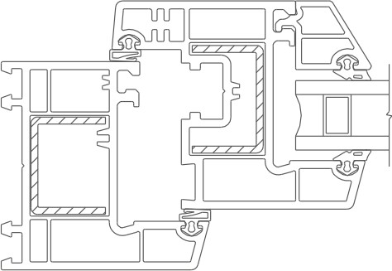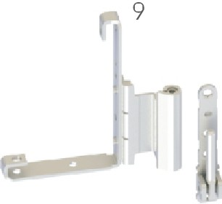8

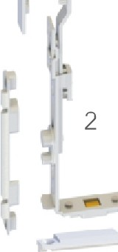

-

15

14

6 -�-

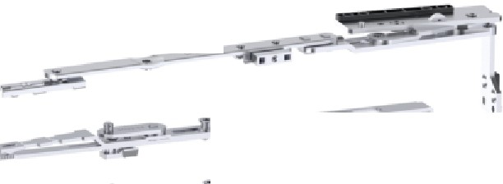

5

6A

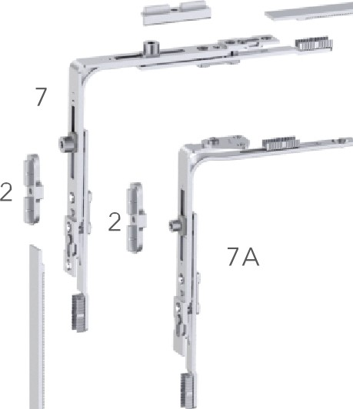2 -

###### 2 .

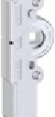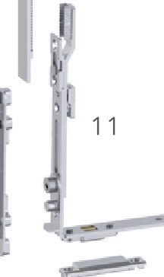

8

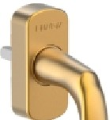

14

9

10

#### SGSX103 THE TILT AND TURN HARDWARE SYSTEM FOR U-PVC(9/13)

2

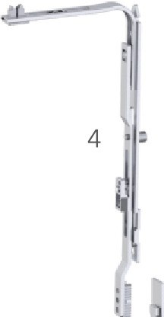

3

|  |  |  |  |  |
| --- | --- | --- | --- | --- |
| NO. | NAME | ITEM NO. | NUMBER | NOTE |
| 1 | BOTTOM PIVOT HINGE | SGSX103-01 | 1 |  |
| 2 | KEEPER | CGK015/CGK017 | 3-5 | optional |
| 3 | CONNECTOR ROD | CGYCG02 | 1 |  |
| 4 | CORNER DEVICE | CGZJS02 | 1 |  |
| 5 | CONNECTOR ROD | CGSGSX103-02 | 1 |  |
| 6 | SASH STAY GUIDE | CGSGSX103-03 | 1 |  |
| 6A | SASH STAY GUIDE | CGSGSX103-04 | 1 | optional |
| 7 | CORNER DEVICE | CGZXJ04 | 1 |  |
| 7A | CORNER DEVICE | CGZXJ01 C | 1 | optional |
| 8 | TRANSMITTER | CGCDG75E | 1 |  |
| 9 | ANTI-MISOPERATION BLOCK | CGFWO01 | 1 |  |
| 10 | LIFTING BASE | CGTO01 | 1 |  |
| 11 | TURN SUPPORT | CGFZ05 | 1 |  |
| 12 | SUPPORTING BLOCK | CGFZ05-01 | 1 |  |
| 13 | ANTI-FALL BLOCK | CGFZ05-02 | 1 |  |
| 14 | HANDLE | CGZS072-CD | 1 | optional |

##### INSTRUCTION

2 **1.** Suit for sash width between 530-830mm,sash height 685-171 0mm.

2.Capacity 60Kg,suggested proportion of window width/window height at 1:1.5.

##### TECHNICAL PARAMETERS

TRANSMITTER

|  |  |
| --- | --- |
| MODEL | SASH HEIGHT RANGE |
| 800mm | 685-1110mm |
| 1000mm | 885-1310mm |
| 1200mm | 1085-151Om m |
| 1400mm | 1310-1710mm |

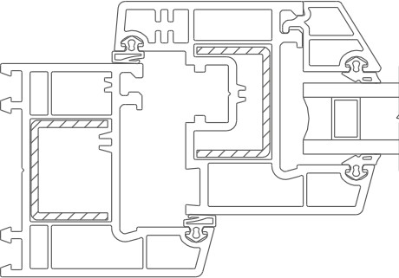 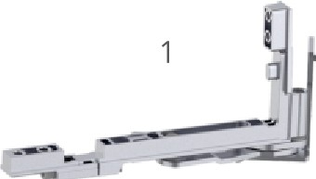

\ /;

*/1*

\; I

,,, ,,, \ *I*

II

*'{*

I '

*I* ,, ,,-

\

13

14

12

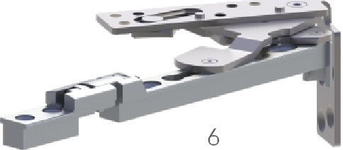 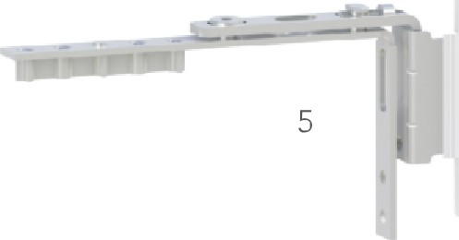

#### CASEMENTWINDOW HARDWARE CONFIGURATION

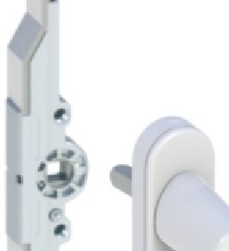

|  |  |  |  |  |
| --- | --- | --- | --- | --- |
| NO. | NAME | ITEM NO. | NUMBER | NOTE |
| 1 | HANDLE | CGZS042-CD | 1 | optional |
| 2 | TRANSMITTER | CGCD003-SG | 1 |  |
| 3 | KEEPER | CGK015 | 2-4 |  |
| 4 | ESPAGNOLETTE GEARS | CGCD00S-SG | 1 | optional |
| 5 | KEEPER | CGK028 | 2-4 | optional |
| 6 | UPPER CONCEALED HINGE | SYJ02 | 1 |  |
| 7 | BOOTTOM CONCEALED HINGE | SYJ02 | 1 |  |
| 8 | SUPPORTING BLOCK | CGZSK03-S | 1 |  |
| 9 | MID PIVOT HINGE | SYK01 | 1 | optional |

5 3

#### INSTRUCTION

1.Capacity 60Kg,suggested proportion of window width/window height at 1:1.5.

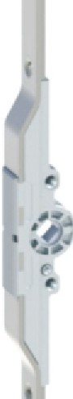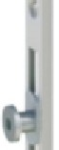

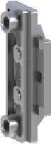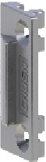

9

#### CASEMENTWINDOW HARDWARE CONFIGURATION

3

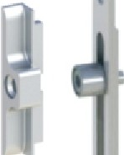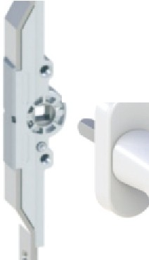

|  |  |  |  |  |
| --- | --- | --- | --- | --- |
| NO. | NAME | ITEM NO. | NUMBER | NOTE |
| 1 | HANDLE | CGZS016-CD | 1 | optional |
| 2 | TRANSMITTER | CGCD003-SG | 1 |  |
| 3 | KEEPER | CGK015 | 2-4 |  |
| 4 | TRANSMITTER | CGCD006-SG | 1 | optional |
| 5 | UPPER HINGE | CGJL020S-01 | 1 |  |
| 6 | MIDDLE HINGE | CGJL020SB-03 | 1 |  |
| 7 | BOTTOM HINGE | CGJL020S-02 | 1 |  |
| 8 | STAY ARMS | CGFC004D | 1 | optional |
| 9 | SUPPORTING BLOCK | CGZSK03-S | 1 |  |

4

### 2 INSTRUCTION

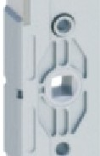1.Capacity 90Kg,suggested proportion of window width/window height at 1:1.5.

6

###### 2

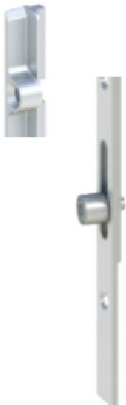

3

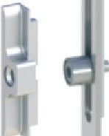

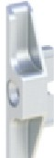3

###### 5

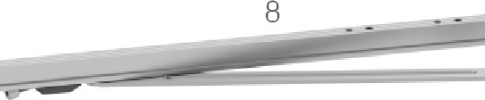

8 9

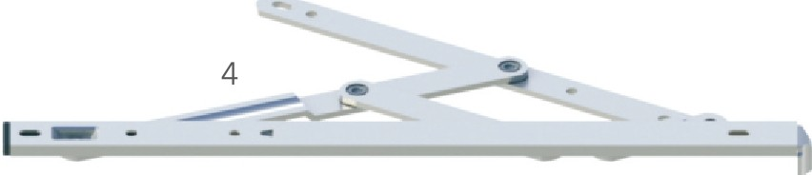

#### CASEMENT WINDOW HARDWARE CONFIGURATION

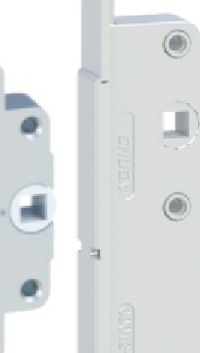

3

|  |  |  |  |  |
| --- | --- | --- | --- | --- |
| NO. | NAME | ITEM NO. | NUMBER | NOTE |
| 1 | HANDLE | CGZS0 14C-CD | 1 | optional |
| 2 | TRANSMITTER | CGCD001-SG | 1 |  |
| 3 | KEEPER | CGK015 | 2-4 |  |
| 4 | FRICTION HINGES | CGHC001-18 | 2 |  |
| 5 | SUPPORTING BLOCK | CGZSK03-S | 1 |  |
| 6 | TRANSMITTER | CGCD012-SG | 1 | optional |
| 7 | ANTI-FALL BLOCK | CGFZS01-S | 1 | optional |

TOP-HUNG CASEMENT WINDOW HARDWARE CONFIGURATION

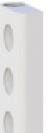

### INSTRUCTION 7

* 1. Suit for sash width Less than 570mm.
  2. Ca pa city 60Kg,suggested proportion of window width/window height at 1:1.5.

2

I

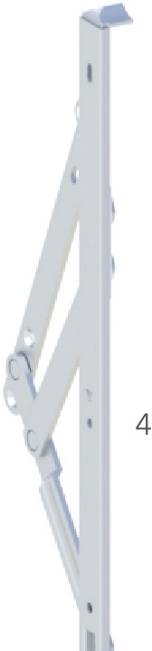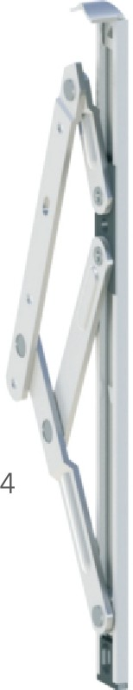'-

|  |  |  |  |  |
| --- | --- | --- | --- | --- |
| NO. | NAME | ITEM NO. | NUMBER | NOTE |
| 1 | HANDLE | CGZS015-CD | 1 | optional |
| 2 | TRANSMITTER | CGCD001-SG | 1 |  |
| 3 | KEEPER | CGK015 | 2 |  |
| 4 | FRICTION HINGES | CGHC002-18 | 2 |  |
| 5 | STAY ARMS | CGFC010 | 2 |  |

### INSTRUCTION

1.The level of load bearing depends on the friction hinge specification. 2.suggested proportion of window width/window height at 1:1.5.

I 5

5

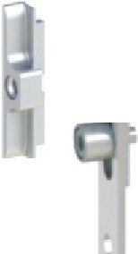

3

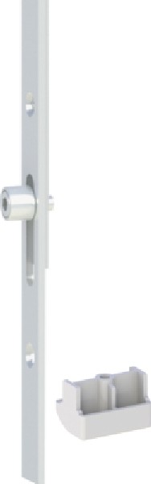

6

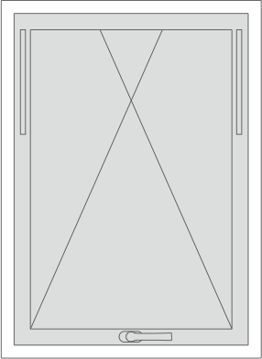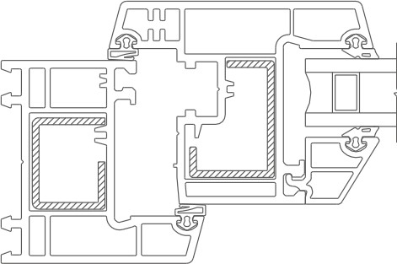

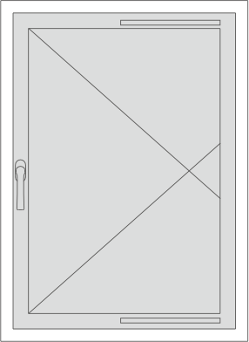 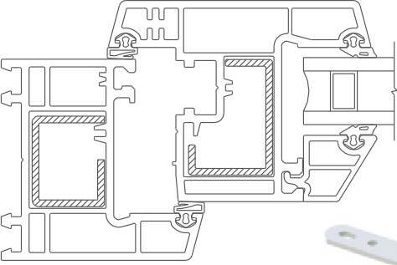 4 I



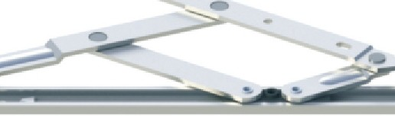

•

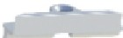3 3

5

#### CASEMENT DOOR HARDWARE CONFIGURATION 6

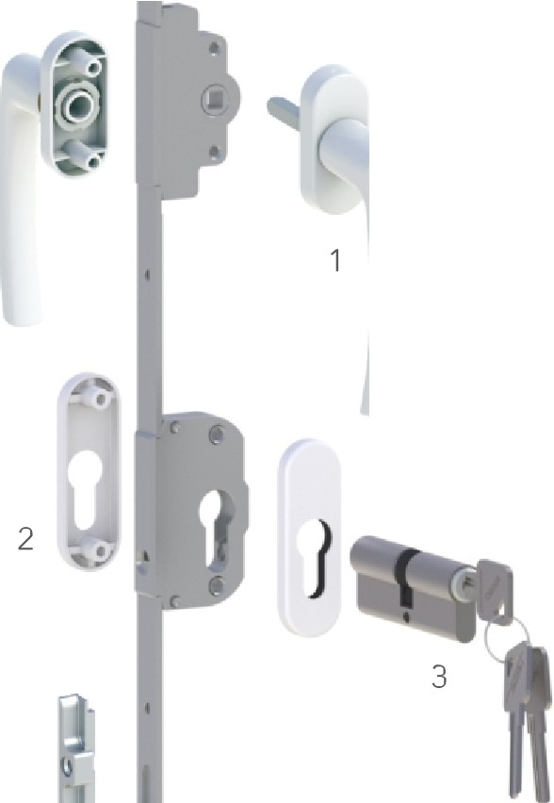

###### 5

|  |  |  |  |  |
| --- | --- | --- | --- | --- |
| NO. | NAME | ITEM NO. | NUMBER | CASE PACK |
| 1 | HANDLE | CGZS022-SG | 1 | � |
| 2 | COVER PLATE | CGSG004 | 1 |
| 3 | CYLINDER | CGSX002 | 1 |
| 4 | TRANSMITTER | CGCD025C-SG | 1 | � |
| 5 | KEEPER | CGK016 | 4 |
| 6 | UPPER HINGE | CGJL020S-01 | 1 | @ |
| 7 | BOTTOM HINGE | CGJL020S-02 | 1 |
| 8 | MIDDLE HINGE | CGJL020SB-03 | 1 | @ |



5

#### CASEMENT DOOR HARDWARE CONFIGURATION

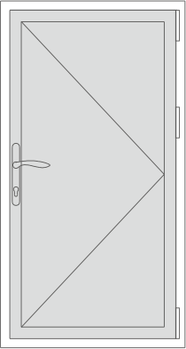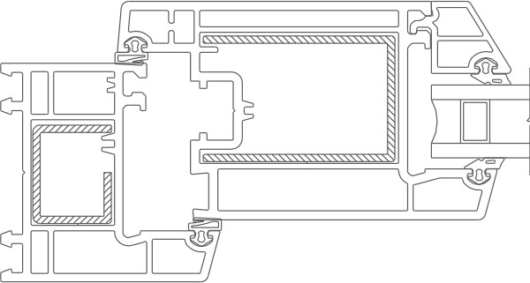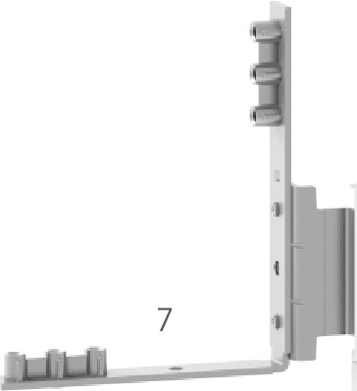

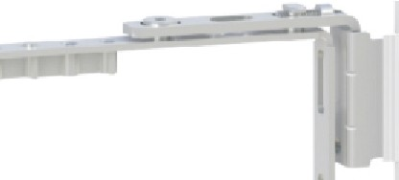

5

4

### INSTRUCTION

1. 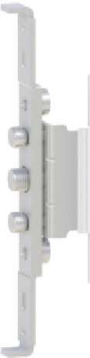Capacity 90Kg,the maximum load bearing is related to the door width to height ratio and glass thickness.
2. Suggested proportion of window width/window height at 1:1.5.

8

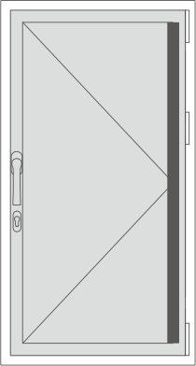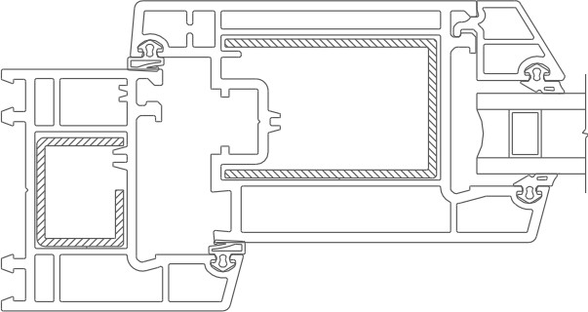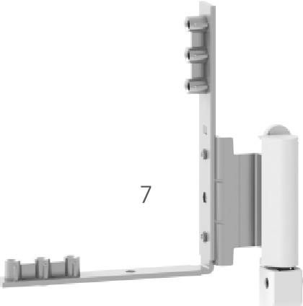5

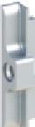

###### 5

#### INSTRUCTION

|  |  |  |  |  |
| --- | --- | --- | --- | --- |
| NO. | NAME | ITEM NO. | NUMBER | NOTE |
| 1 | HANDLE | CGDMS8525-LS | 1 | optionaI |
| 2 | DOOR LOCK | CGST8525-S | 1 |  |
| 3 | LOCK PLATE | MSK9 | 1 |  |
| 4 | CYLINDER | CGSX002 | 1 | optionaI |
| 5 | UPPER HINGE | CGJL020S-01 | 1 |  |
| 6 | MIDDLE HINGE | CGJL020SB-03 | 1 |  |
| 7 | BOTTOM HINGE | CGJL020S-02 | 1 |  |
| 8 | HANDLE | CGDMS5025-LS | 1 | optionaI |
| 9 | DOOR LOCK | CGST5025-S | 1 | optionaI |
| 10 | LOCK PLATE | MSK6325-06 | 1 | optionaI |

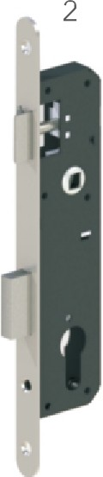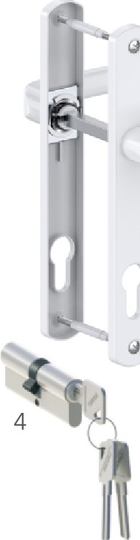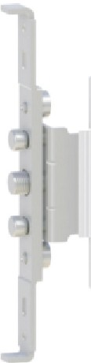1.Capacity 90Kg,the maximum load bearing is related to the door width to height ratio and glass thickness.

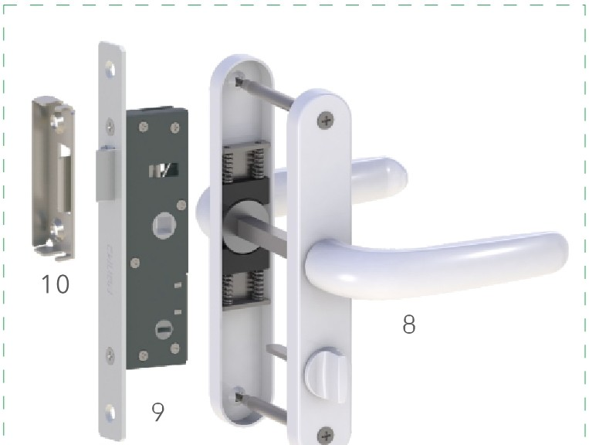6

3

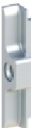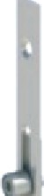3

I,...-

4

#### CASEMENT DOOR HARDWARE CONFIGURATION

6 CASEMENT DOOR HARDWARE CONFIGURATION

7

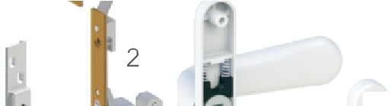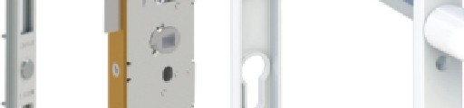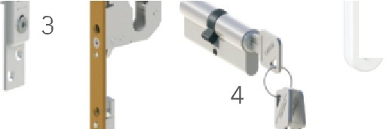

-

|  |  |  |  |  |
| --- | --- | --- | --- | --- |
| NO. | NAME | ITEM NO. | NUMBER | CASE PACK |
| 1 | DOOR HANDLE | CGDMS033D-LS | 1 | � |
| 2 | LOCK BODY | CGST30-S | 1 |
| 3 | LOCK PLATE | MSK12 | 1 |
| 4 | CYLINDER | CGSX002 | 1 |
| 5 | CONNECTING ROD | CGLJ735 | 2 | � |
| 6 | KEEPER | CGK016 | 4 |
| 7 | DOOR HINGE | CGPMJ3DB-S | 3 | � |

5

6

### INSTRUCTION

|  |  |  |  |  |
| --- | --- | --- | --- | --- |
| NO. | NAME | ITEM NO. | NUMBER | NOTE |
| 1 | HANDLE | CGZS021-SG | 1 | optional |
| 2 | TRANSMITTER | CGCD024-SG | 1 |  |
| 3 | KEEPER | CGK016 | 4 |  |
| 4 | HINGE | CGJL3D-90 | 3 |  |

3 1.Capacity 90Kg,the maximum load bearing is related to the door width to height ratio and glass thickness.

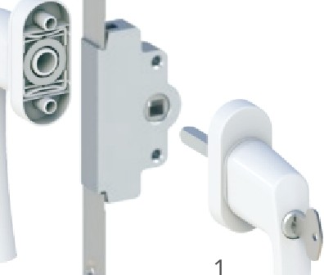2

:,-·

1,.,-

### INSTRUCTION

1. Capacity 90Kg,the maximum load bearing is related to the door width to height ratio and glass thickness.

, -

-

4

7

,

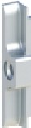3

6

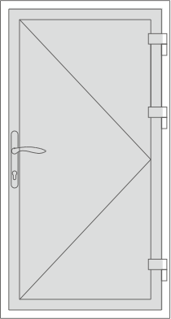5

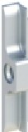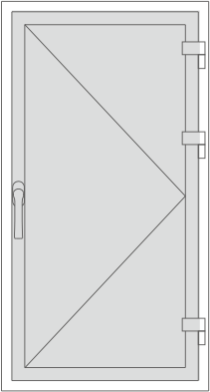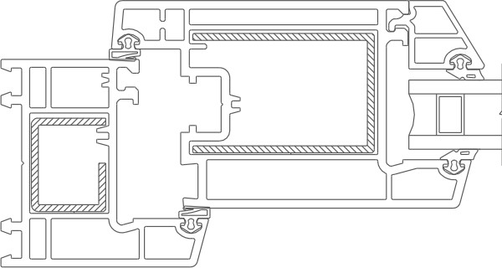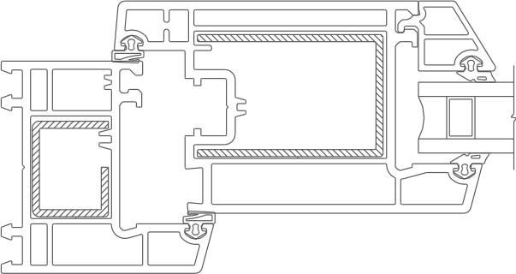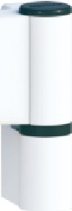3 6

4

7

#### SLIDING WINDOW HARDWARE CONFIGURATION

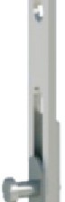

3

|  |  |  |  |  |
| --- | --- | --- | --- | --- |
| NO. | NAME | ITEM NO. | NUMBER | NOTE |
| 1 | HANDLE | CGZS036-CD | 1 | optional |
| 2 | TRANSMITTER | CGCD003T-SG | 1 |  |
| 3 | KEEPER | CGK023 | 2 | optional |
| 4 | TOUCH LOCK | CGBS013-LS | 1 | optional |
| 5 | ROLLER | CGHL003-88 | 2 | optional |
| 6 | ROLLER | CGHL001-88 | 2 | optional |

### INSTRUCTION

* 1. The maximum load bearing is related to the door width to height ratio and glass thickness.
  2. The above configuration is the dosage of a window.

#### SLIDING DOOR HARDWARE CONFIGURATION

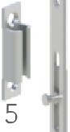5

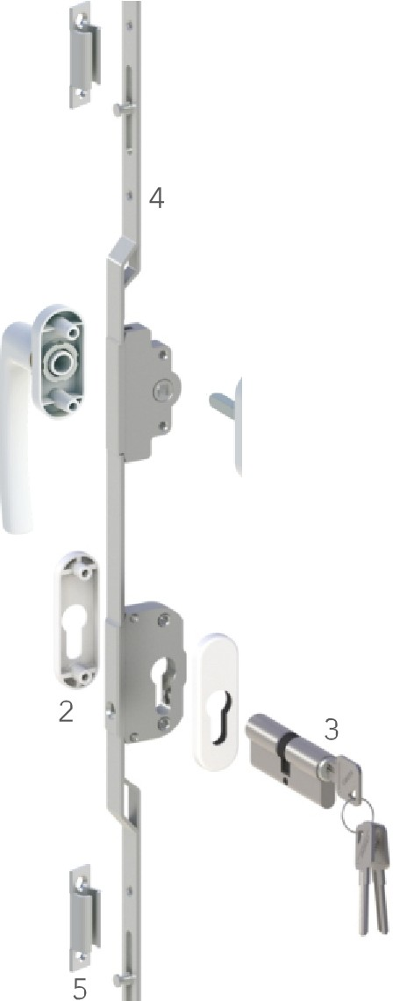

|  |  |  |  |  |
| --- | --- | --- | --- | --- |
| NO. | NAME | ITEM NO. | NUMBER | CASEPACK |
| 1 | HANDLE | CGZS022-SG | 1 | (fa |
| 2 | COVER PLATE | CGSG004 | 1 |
| 3 | CYLINDER | CGSX002 | 1 |
| 4 | TRANSMITTER | CGCD025D-SG | 1 | (fa |
| 5 | KEEPER | CGK023 | 4 |
| 6 | ROLLER | CGHL009-88 | 2 | @ |
| 7 | ROLLER | CGHL025B | 2 | @ |

### INSTRUCTION

1. The maximum load bearing is related to the door width to height ratio and glass thickness.
2. The above configuration is the dosage of a door.

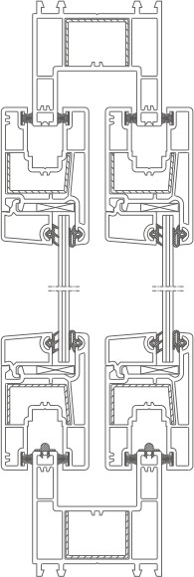***r***

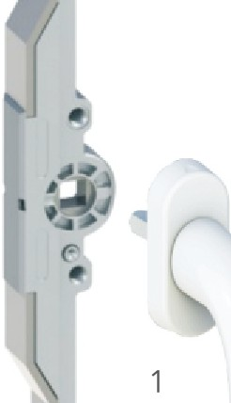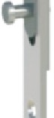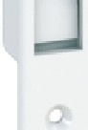

I

�

I

�

4

###### 2

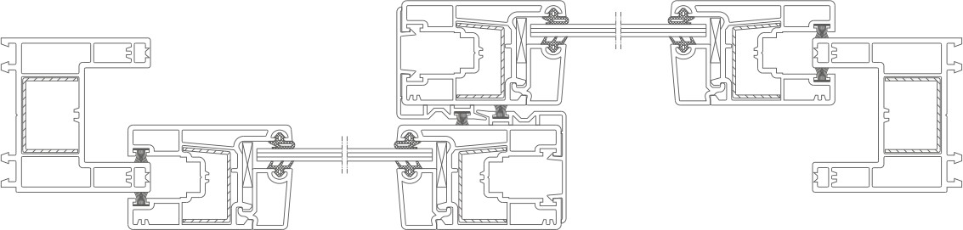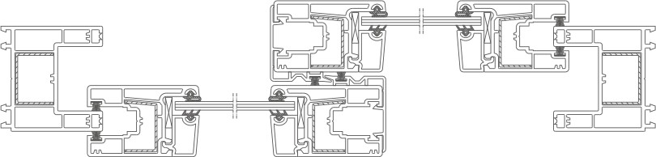

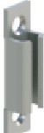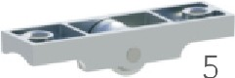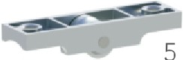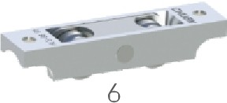3

5 7

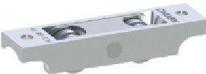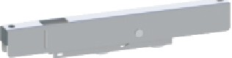7

6 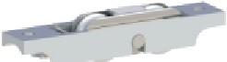 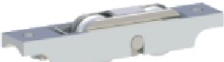

6 6

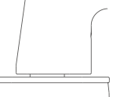

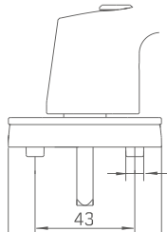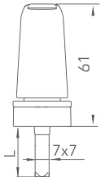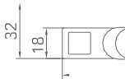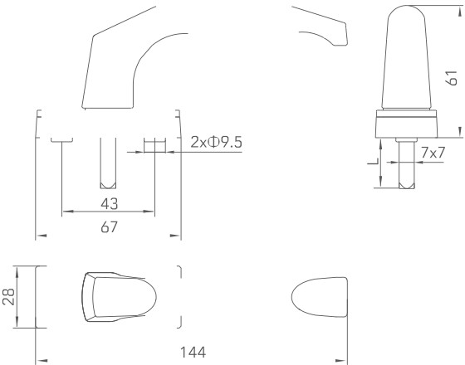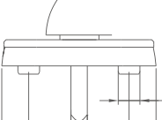

|  |  |  |  |  |  |  |  |
| --- | --- | --- | --- | --- | --- | --- | --- |
|  | ITEM NO. | CGZS001-CD | | 2xcD9.5  66  ��  150 |  | _I |  |
| MATERIAL | HANDLE:ALUMINUM BASE:ZINC | |
| PACKAGING | 80 PCS/CTN | |
|  | | |
|  | ITEM NO. | CGZS002-CD |  | m=-c,  /�-'j  166 | | | |
| MATERIAL | HANDLE:ALUMINUM BASE:ZINC | |
| PACKAGING | 100 PCS/CTN | |
|  | | |
|  | ITEM NO. | CGZS003-CD | | 2x©9.5  �p6=6  N 145 | J | I | Q: |
| MATERIAL | HANDLE:ALUMINUM BASE:ALUMINUM OR PLASTIC | |
| PACKAGING | 100 PCS/CTN | |
|  | | |
|  | ITEM NO. | CGZS004-CD | | *[J*  r - +rJ-'  4[C: 152 | *�* |  | *�* |
| MATERIAL | HANDLE:ALUMINUM BASE:PLASTIC | |
| PACKAGING | 100 PCS/CTN | |
|  | | |
|  | ITEM NO. | **CGZS007-CD** | |  | | | |
| MATERIAL | HANDLE:ALUMINUM BASE:PLASTIC | |
| PACKAGING | 100 PCS/CTN | |
|  | | |

|  |  |  |  |
| --- | --- | --- | --- |
| \  �  � 5  ��  173 � | ITEM NO. | **CGZS00BB-CD** |  |
| MATERIAL | HANDLE:ALUMINUM BASE:ALUMINUM |
| PACKAGING | 80 PCS/CTN |
|  | |
| \"�  ill 2x©9.5  66  �� j  N 139 | ITEM NO. | **CGZS009-CD** |  |
| MATERIAL | HANDLE:ALUMINUM BASE:PLASTIC |
| PACKAGING | 100 PCS/CTN |
|  | |
|  | ITEM NO. | **CGZS010-CD** |  |
|  | MATERIAL | HANDLE:ALUMINUM BASE:PLASTIC |
| *J* |  |  |
| PACKAGING | 100 PCS/CTN |
| 2xcD9.5 |
|  | |
| 1 CQ: |
| 143 |
|  | ITEM NO. | **CGZS011-CD** |  |
| MATERIAL | HANDLE:ALUMINUM BASE:ZINC |
| PACKAGING | 100 PCS/CTN |
| 2x©9.5  � |
|  | |
| l-43  66  1([g: j |
| 150 |  | |  |
| *Ir w*  �  43_  62  �If m:  160 | ITEM NO. | **CGZS013-CD** |  |
| MATERIAL | HANDLE:ZINC BASE:ZINC |
| PACKAGING | 100 PCS/CTN |
|  | |

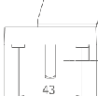

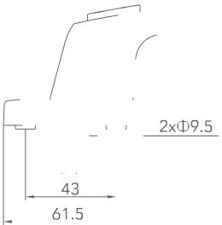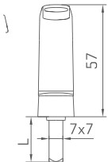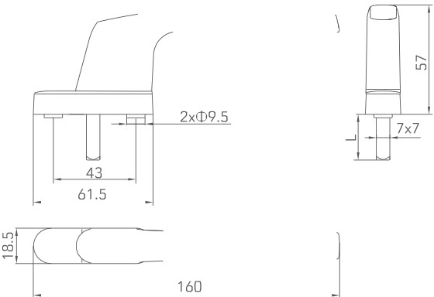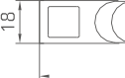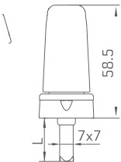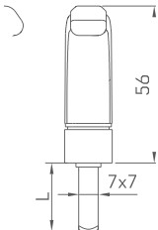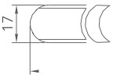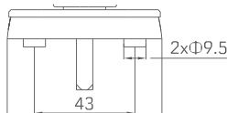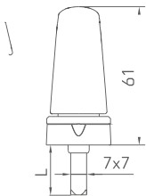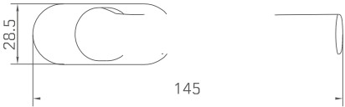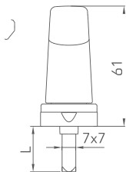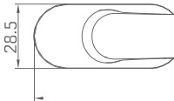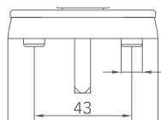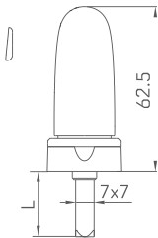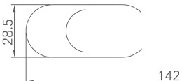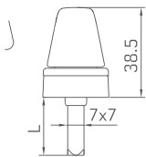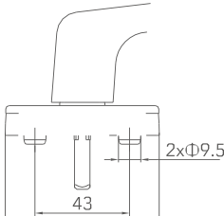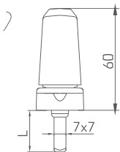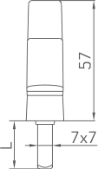

|  |  |  |  |
| --- | --- | --- | --- |
|  | ITEM NO. | CGZS014-CD | (0  160 |
| MATERIAL | HANDLE:ZINC BASE:ZINC |
| PACKAGING | 100 PCS/CTN |
|  | |
|  | ITEM NO. | **CGZS014C-CD** |  |
| MATERIAL | HANDLE:ALUMINUM BASE:ALUMINUM |
| PACKAGING | 100 PCS/CTN |
|  | |
|  | ITEM NO. | **CGZS015-CD** | **2x©9.S**  63  161 |
| MATERIAL | HANDLE:ALUMINUM BASE:ZINC |
| PACKAGING | 100 PCS/CTN |
|  | |
|  | ITEM NO. | **CGZS016-CD** | �  ��  **N 152** |
| MATERIAL | HANDLE:ALUMINUM BASE:PLASTIC |
| PACKAGING | 100 PCS/CTN |
|  | |
|  | ITEM NO. | **CGZS018-CD** | *L_(*  ill74  137 |
| MATERIAL | HANDLE:ZINC BASE:ZINC |
| PACKAGING | 100 PCS/CTN |
|  | |

|  |  |  |  |
| --- | --- | --- | --- |
| 66 | ITEM NO. | CGZS023B-CD |  |
| MATERIAL | HANDLE:ALUMINUM BASE:PLASTIC |
| PACKAGING | 100 PCS/CTN |
|  | |
| *L*  il67l  148 | ITEM NO. | **CGZS024-CD** |  |
| MATERIAL | HANDLE:ALUMINUM BASE:PLASTIC |
| PACKAGING | 100 PCS/CTN |
|  | |
| **2xCD9.5**  66 | ITEM NO. | **CGZS032-CD** |  |
| MATERIAL | HANDLE:ALUMINUM BASE:PLASTIC |
| PACKAGING | 100 PCS/CTN |
|  | |
| �  ��  N 145 | ITEM NO. | **CGZS034-CD** |  |
| MATERIAL | HANDLE:ALUMINUM BASE:PLASTIC |
| PACKAGING | 100 PCS/CTN |
|  | |
| 43  70  �rT [CJ  l **:.;145** | ITEM NO. | **CGZS035B-CD** |  |
| MATERIAL | HANDLE:ALUMINUM BASE:ALUMINUM |
| PACKAGING | 100 PCS/CTN |
|  | |

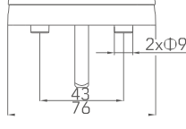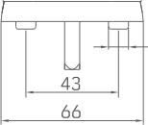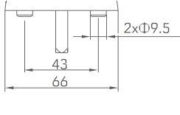

|  |  |  |  |  |
| --- | --- | --- | --- | --- |
|  | ITEM NO. | **CGZS036-CD** | 2x<D9.5  1 c:  144 | M,J |
| MATERIAL | HANDLE:ZINC BASE:PLASTIC |
| PACKAGING | 100 PCS/CTN |
|  | |
|  |
|  | ITEM NO. | **CGZS038-CD** | j  rn115-=tj  Mif= ( :  173 J | |
| MATERIAL | HANDLE:ALUMINUM BASE:ALUMINUM |
| PACKAGING | 100 PCS/CTN |
|  | |
|  | ITEM NO. | **CGZS039-CD** | .5 I  �  158 � | |
| MATERIAL | HANDLE:ALUMINUM BASE:ALUMINUM |
| PACKAGING | 100 PCS/CTN |
|  | |
|  | ITEM NO. | **CGZS042-CD** | ,[ �"  1 b cI: :  151 J | |
| MATERIAL | HANDLE:ALUMINUM BASE:PLASTIC |
| PACKAGING | 100 PCS/CTN |
|  | |
|  | ITEM NO. | **CGZS046B-CD** | *Lr*  l l]"'··· *�*  C'  � 153 -1 | |
| MATERIAL | HANDLE:ALUMINUM BASE:ALUMINUM |
| PACKAGING | 100 PCS/CTN |
|  | |

|  |  |  |  |
| --- | --- | --- | --- |
| �  �  {fI==,s,  J | ITEM NO. | **CGZS047-CD** |  |
| MATERIAL | HANDLE:ALUMINUM BASE:ALUMINUM |
| PACKAGING | 100 PCS/CTN |
|  | |
| D i i  7  � 2 | ITEM NO. | **CGZS049-CD** |  |
| MATERIAL | HANDLE:ZINC BASE:ZINC |
| PACKAGING | 100 PCS/CTN |
|  | |
| a3 i *aJ*  4 (CO) �  **160.7** | ITEM NO. | **CGZS050-CD** |  |
| MATERIAL | HANDLE:ALUMINUM BASE:ALUMINUM |
| PACKAGING | 100 PCS/CTN |
|  | |
| � *}w*  lllr  rp:=1535 l | ITEM NO. | **CGZS051-CD** |  |
| MATERIAL | HANDLE:ZINC BASE:PLASTIC |
| PACKAGING | 100 PCS/CTN |
|  | |
| m**2x** **<D9.S** *al*  �If (@  159 | ITEM NO. | **CGZS053B-CD** |  |
| MATERIAL | HANDLE:ZINC BASE:ZINC |
| PACKAGING | 100 PCS/CTN |
|  | |

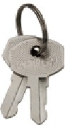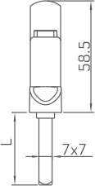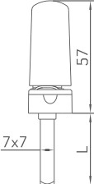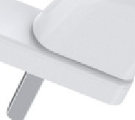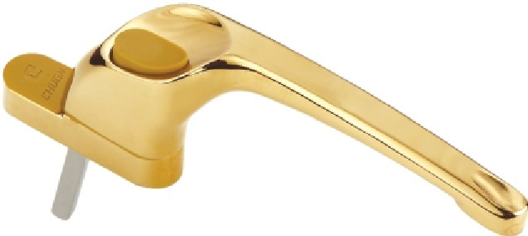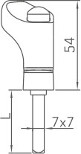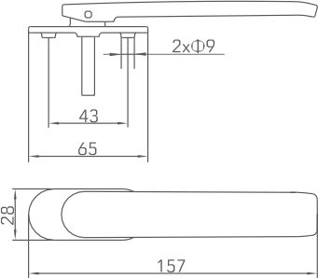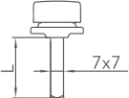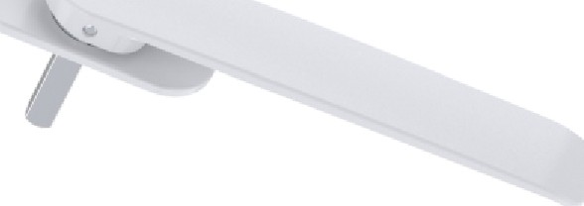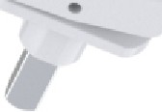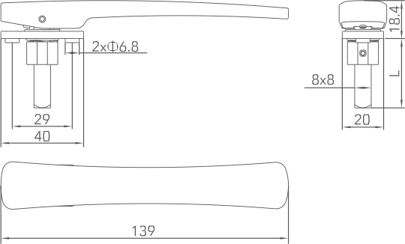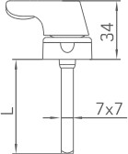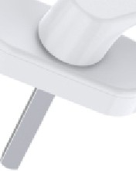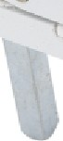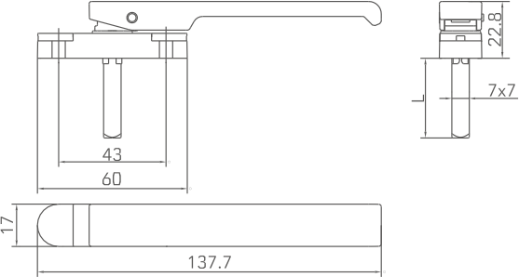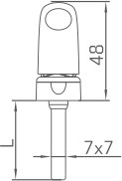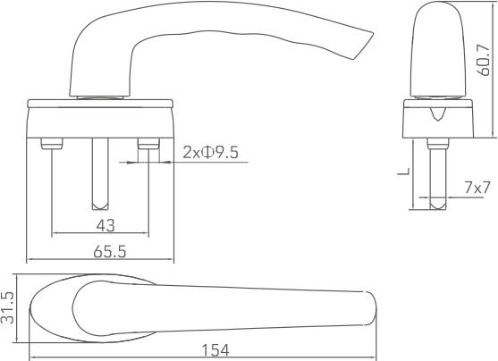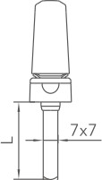

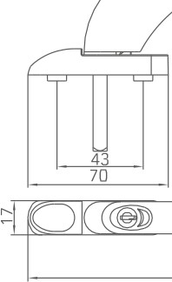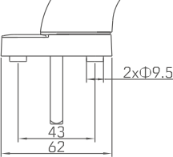

ITEM NO.

MATERIAL

CGZS054-CD

HANDLE:ALUMINUM BASE:ZINC

PACKAGING 100 PCS/CTN

165.7

ITEM NO.

MATERIAL

CGZS055-CD

HANDLE:ZINC BASE:ZINC

PACKAGING 60 PCS/CTN

� 162

ITEM NO.

MATERIAL

CGZS057-CD

HANDLE:ZINC BASE:ZINC

PACKAGING 100 PCS/CTN

ITEM NO.

MATERIAL

CGZS064-CD

HANDLE:ZINC BASE:ZINC

PACKAGING 100 PCS/CTN

ITEM NO.

MATERIAL

**CGZS065-CD**

HANDLE:ALUMINUM BASE:PLASTIC

PACKAGING 80 PCS/CTN

•

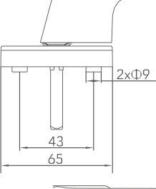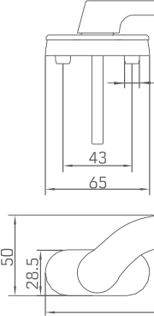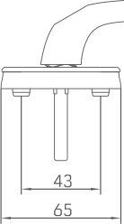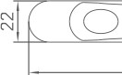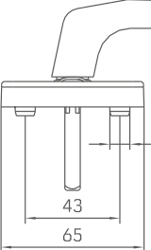

ITEM NO.

MATERIAL

CGZS070-CD

HANDLE:ALUMINUM BASE:ZINC

L

R

PACKAGING 100 PCS/CTN

~~1~~r--fc_�161-.5 ,

ITEM NO.

MATERIAL

CGZS071B-CD

HANDLE:ZINC BASE:STAINLESS STEEL

PACKAGING 100 PCS/CTN

ITEM NO.

MATERIAL

CGZS074-CD

HANDLE:ZINC BASE:ZINC

L

R

2x©9.5

PACKAGING 60 PCS/CTN

171.5

ITEM NO.

MATERIAL

CGZS079-CD

HANDLE:ALUMINUM BASE:ALUMINUM

PACKAGING 100 PCS/CTN

*I*

143

ITEM NO.

MATERIAL

**CGZS093-CD**

HANDLE:ALUMINUM BASE:ALUMINUM

PACKAGING 100 PCS/CTN

2xCD9.5

ail >--f 14_3

,

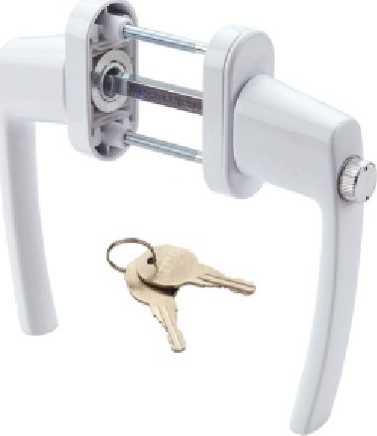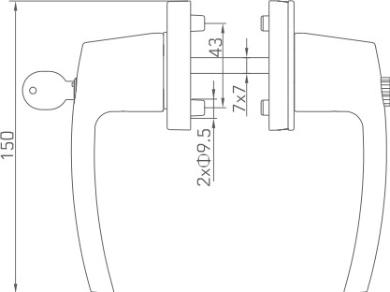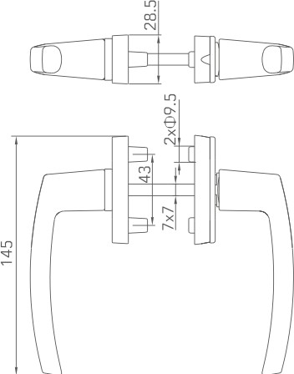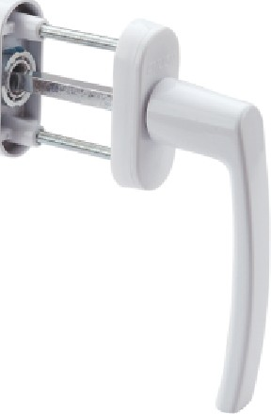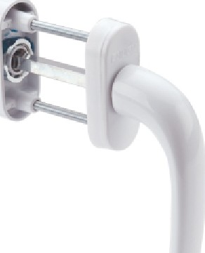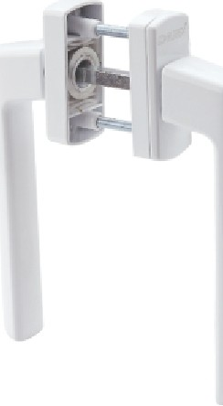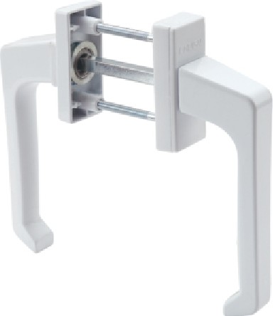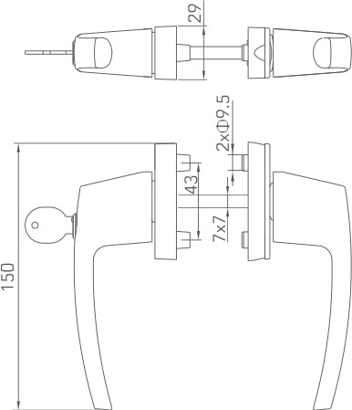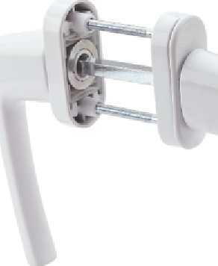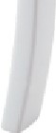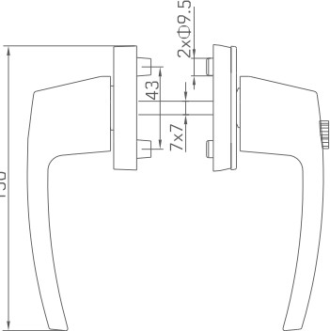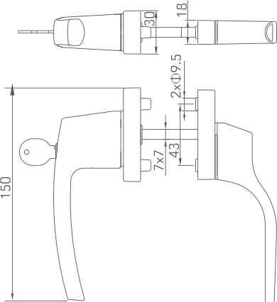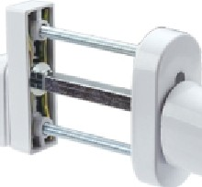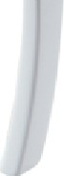

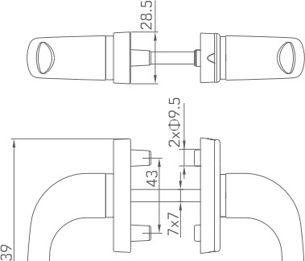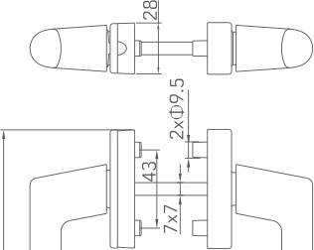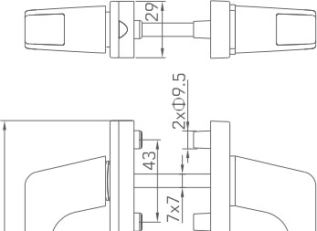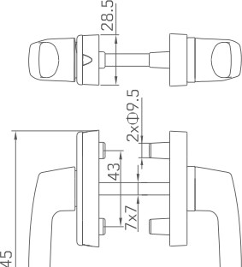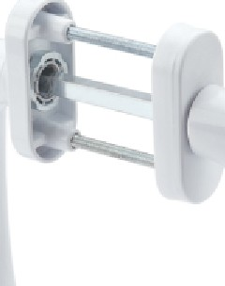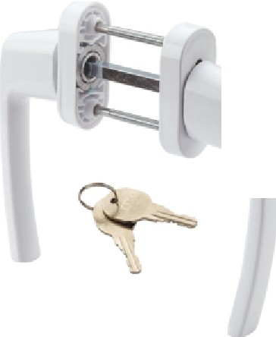

*fJ*

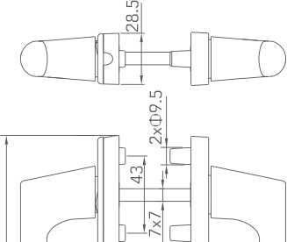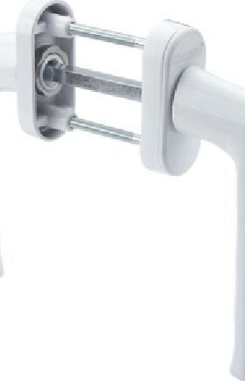

ITEM NO.

CGZS018-SG

MATERIAL

HANDLE:ALUMINUM BASE:ZINC&ALUMINUM

�

PACKAGING

40 SETS/CTN

ITEM NO.

MATERIAL

CGZS019-SG

HANDLE:ALUMINUM BASE:ALUMINUM

PACKAGING

40 SETS/CTN

ITEM NO.

MATERIAL

CGZS020-SG

HANDLE:ALUMINUM BASE:ALUMINUM&PLASTI C

PACKAGING

40 SETS/CTN

ITEM NO.

MATERIAL

CGZS021-SG

HANDLE:ALUMINUM BASE:ALUMINUM&PLASTIC

PACKAGING

40 SETS/CTN

ITEM NO.

**CGZS021B-SG**

MATERIAL

HANDLE:ALUMINUM BASE:ZINC&ALUMINUM

�

PACKAGING

40 SETS/CTN

ITEM NO.

MATERIAL

CGZS022-SG

HANDLE:ALUMINUM BASE:ALUMINUM

PACKAGING

40 SETS/CTN

ITEM NO.

MATERIAL

CGZS023-SG

HANDLE:ALUMINUM BASE:ALUMINUM

PACKAGING

40 SETS/CTN

ITEM NO.

MATERIAL

CGZS024-SG

HANDLE:ALUMINUM BASE:ALUMINUM

PACKAGING

40 SETS/CTN

ITEM NO.

MATERIAL

CGZS025-SG

HANDLE:ALUMINUM BASE:ALUMINUM

PACKAGING

40 SETS/CTN

ITEM NO.

MATERIAL

**CGZS027-SG**

HANDLE:ALUMINUM BASE:ZINC&ALUMINUM

PACKAGING

30 SETS/CTN

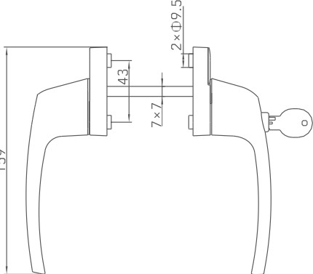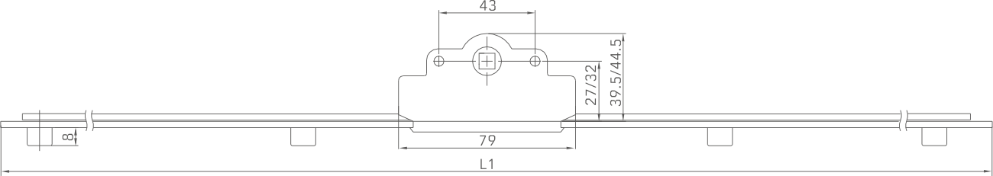

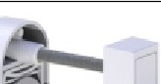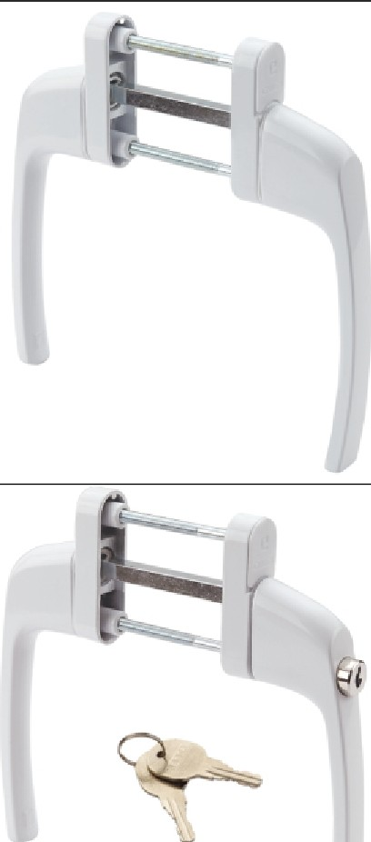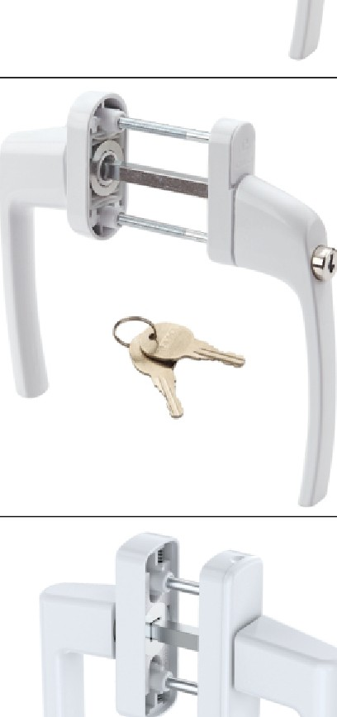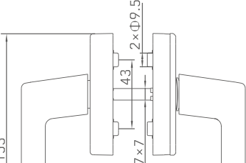

ITEM NO.

I

MATERIAL

CGZS027B-SG

HANDLE:ALUMINUM BASE:ZINC&ALUMINUM

�

PACKAGING 40 SETS/CTN

ITEM NO.

CGZS028-SG

HANDLE:ALUMINUM BASE:ALUMINUM

40 SETS/CTN

ITEM NO.

CGZS028B-SG

HANDLE:ALUMINUM BASE:ALUMINUM&PLASTIC

�

40 SETS/CTN

ITEM NO.

CGZS029-SG

HANDLE:ALUMINUM BASE:ALUMINUM&ZINC

�

40 SETS/CTN

ITEM NO.

CGZS039-SG

HANDLE:ALUMINUM BASE:ALUMINUM

illGCD

40 SETS/CTN

PACKAGING

MATERIAL

PACKAGING

MATERIAL

PACKAGING

MATERIAL

PACKAGING

MATERIAL

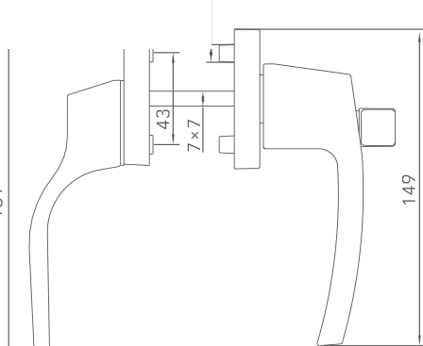

*'!*

N

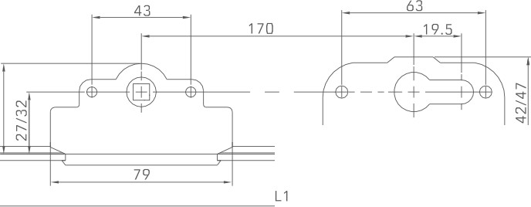

79

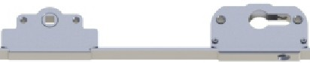

|  |  |
| --- | --- |
| ITEM NO. | CGCD025C-SG |
| MATERIAL | ZINC&CARBON STEEL |
| OPTIONAL | 27/32 |
| PACKAGING | 20 PCS/CTN |

|  |  |
| --- | --- |
| ITEM NO. | CGCD024-SG |
| MATERIAL | ZINC&CARBON STEEL |
| OPTIONAL | 27/32 |
| PACKAGING | 20 PCS/CTN |

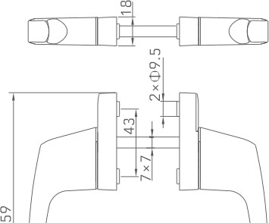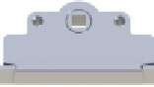

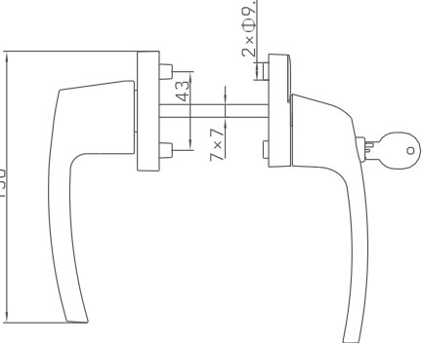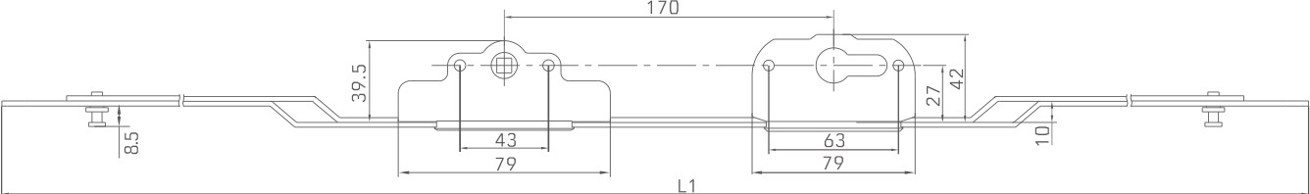

|  |  |
| --- | --- |
| ITEM NO. | CGCD025D-SG |
| MATERIAL | ZINC&CARBON STEEL |
| OPTIONAL | *I* |
| PACKAGING | 20 PCS/CTN |

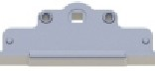

□

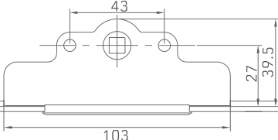

|  |  |
| --- | --- |
| ITEM NO. | CGCD027-SG |
| MATERIAL | ZINC&CARBON STEEL |
| OPTIONAL | *I* |
| PACKAGING | 20 PCS/CTN |

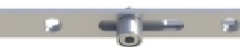

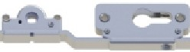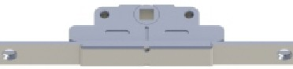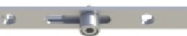

43

|  |  |
| --- | --- |
| ITEM NO. | CGCD032-SG |
| MATERIAL | ZINC&CARBON STEEL |
| OPTIONAL | *I* |
| PACKAGING | 20 PCS/CTN |

|  |  |
| --- | --- |
| ITEM NO. | CGCD001-SG |
| MATERIAL | ZINC&CARBON STEEL |
| OPTIONAL | *I* |
| PACKAGING | 30 PCS/CTN |

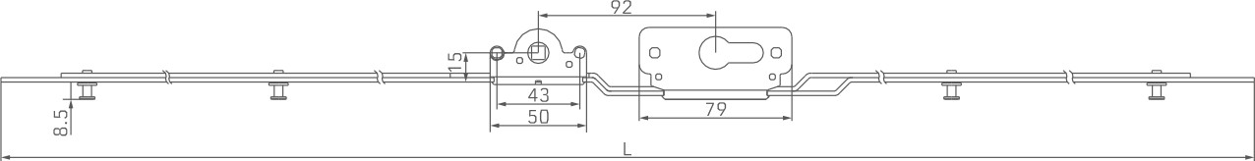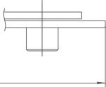

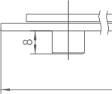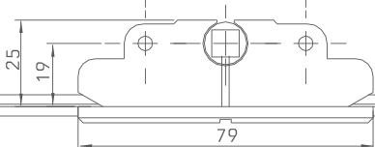

L1

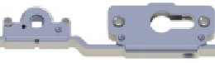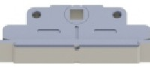

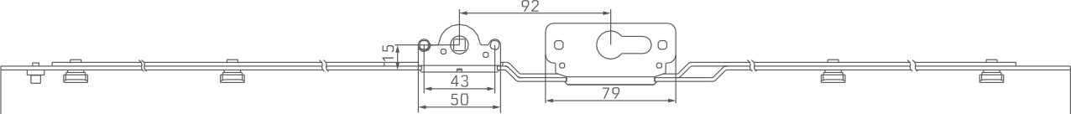 43

|  |  |
| --- | --- |
| ITEM NO. | CGCD032B-SG |
| MATERIAL | ZINC&CARBON STEEL |
| OPTIONAL | *I* |
| PACKAGING | 20 PCS/CTN |

|  |  |
| --- | --- |
| ITEM NO. | CGCD001B-SG |
| MATERIAL | ZINC&CARBON STEEL |
| OPTIONAL | *I* |
| PACKAGING | 30 PCS/CTN |

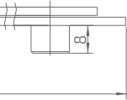

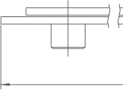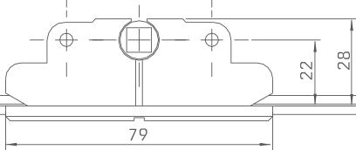

L1

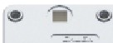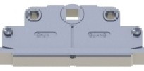

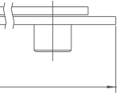 43

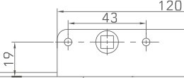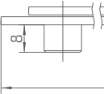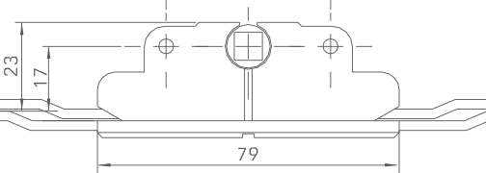

L1

|  |  |
| --- | --- |
| ITEM NO. | CGCD012-SG |
| MATERIAL | ZINC&CARBON STEEL |
| OPTIONAL | *I* |
| PACKAGING | 30 PCS/CTN |

|  |  |
| --- | --- |
| ITEM NO. | CGCD002-SG |
| MATERIAL | ZINC&CARBON STEEL |
| OPTIONAL | *I* |
| PACKAGING | 30 PCS/CTN |



�I======,======J=l=1ig :::::::::::::::::::::::::::::1!]

|  |  |
| --- | --- |
| ITEM NO. | CGCD003-SG |
| MATERIAL | ZINC&CARBON STEEL |
| OPTIONAL | *I* |
| PACKAGING | 30 PCS/CTN |

|  |  |
| --- | --- |
| ITEM NO. | CGCD003T-SG |
| MATERIAL | ZINC&CARBON STEEL |
| OPTIONAL | *I* |
| PACKAGING | 30 PCS/CTN |

rw�a,�1:::::::::::::::::::::::::::::,!7

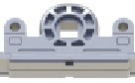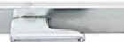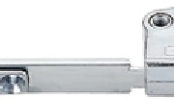

L1

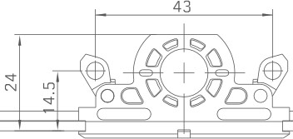

ll3

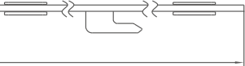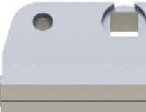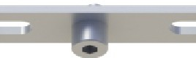

|  |  |
| --- | --- |
| ITEM NO. | CGCD004T-SG |
| MATERIAL | ZINC&CARBON STEEL |
| OPTIONAL | *I* |
| PACKAGING | 30 PCS/CTN |

43

|  |  |
| --- | --- |
| ITEM NO. | CGCD005-L |
| MATERIAL | ZINC&CARBON STEEL |
| OPTIONAL | *I* |
| PACKAGING | 50 PCS/CTN |

## II�

13.61f---=

*1-�i*

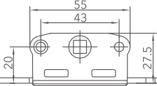M ro

=

|  |  |
| --- | --- |
| ITEM NO. | CGCD009-L |
| MATERIAL | ZINC&CARBON STEEL |
| OPTIONAL | *I* |
| PACKAGING | 30 PCS/CTN |

� *V,*

L1

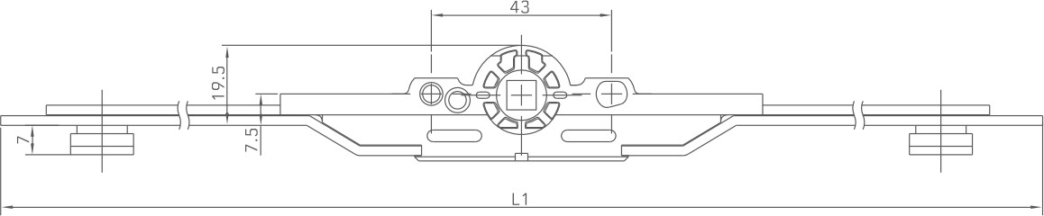 ~~t$~~

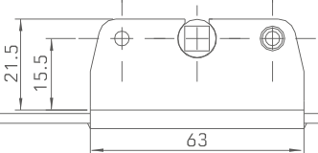

|  |  |
| --- | --- |
| ITEM NO. | CGCD008-SG |
| MATERIAL | ZINC&CARBON STEEL |
| OPTIONAL | *I* |
| PACKAGING | 30 PCS/CTN |

L1

**1:1**

*'CY*

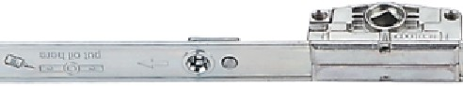

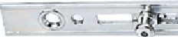

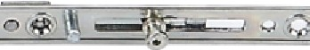

43

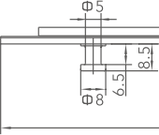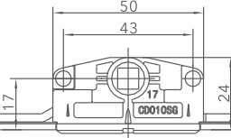

$5

L1

JP

|  |  |
| --- | --- |
| ITEM NO. | CGCD004-L |
| MATERIAL | ZINC&CARBON STEEL |
| OPTIONAL | *I* |
| PACKAGING | 50 PCS/CTN |

|  |  |
| --- | --- |
| ITEM NO. | CGCD010-SG |
| MATERIAL | ZINC&CARBON STEEL |
| OPTIONAL | *I* |
| PACKAGING | 30 PCS/CTN |

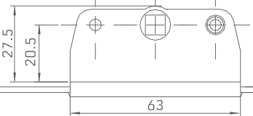 m

L1



_.,_. ......

 43

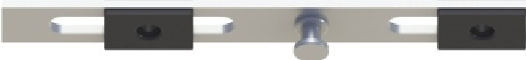

**:w**

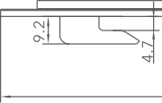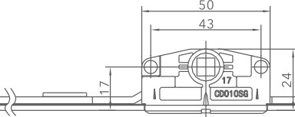

L1

|  |  |
| --- | --- |
| ITEM NO. | CGCD001-L |
| MATERIAL | ZINC&CARBON STEEL |
| OPTIONAL | *I* |
| PACKAGING | 50 PCS/CTN |

|  |  |
| --- | --- |
| ITEM NO. | CGCD010B-SG |
| MATERIAL | ZINC&CARBON STEEL |
| OPTIONAL | *I* |
| PACKAGING | 30 PCS/CTN |

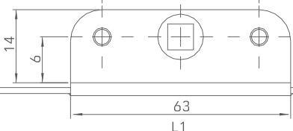

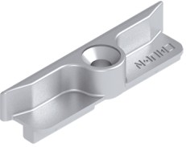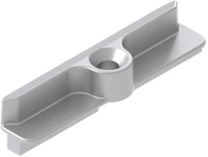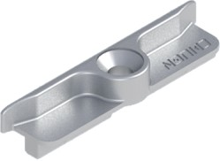� �

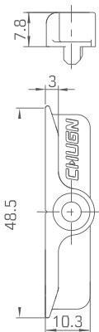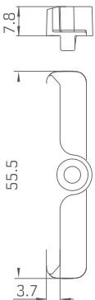

01

00 I .

-'-

�� �

## �_j

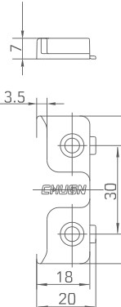

:a

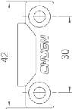

f

2

|  |  |
| --- | --- |
| ITEM NO. | CGK015 |
| TEXTURES | ZINC |

|  |  |
| --- | --- |
| ITEM NO. | CGK015B |
| TEXTURES | ZINC |

|  |  |
| --- | --- |
| ITEM NO. | CGK015O |
| TEXTURES | ZINC |

|  |  |
| --- | --- |
| ITEM NO. | CGK049 |
| TEXTURES | ZINC |

|  |  |
| --- | --- |
| ITEM NO. | CGK051 |
| TEXTURES | ZINC |

|  |  |
| --- | --- |
| ITEM NO. | CGK042 |
| TEXTURES | ZINC |

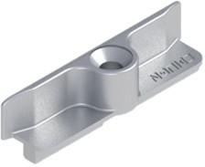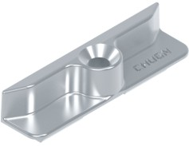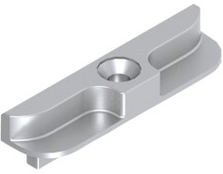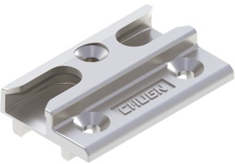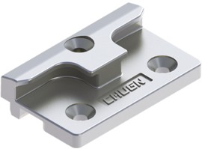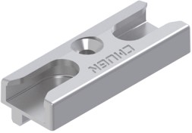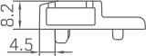��

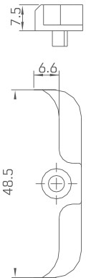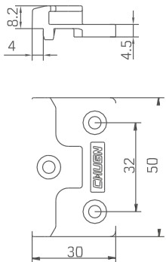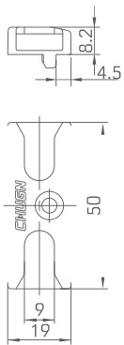

�

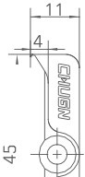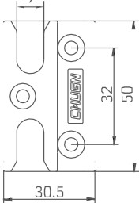

--. 'I"

0�0 �

J_ I

|  |  |
| --- | --- |
| ITEM NO. | CGK015E |
| TEXTURES | ZINC |

|  |  |
| --- | --- |
| ITEM NO. | CGK015F |
| TEXTURES | ZINC |

|  |  |
| --- | --- |
| ITEM NO. | CGK016 |
| TEXTURES | ZINC |

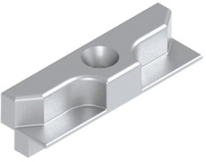 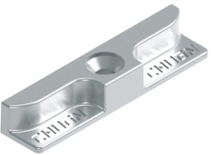 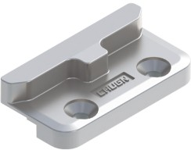

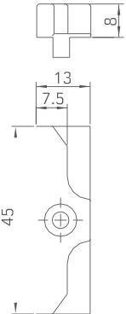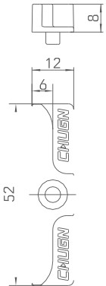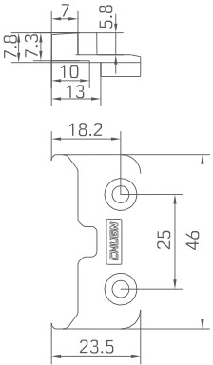

|  |  |
| --- | --- |
| ITEM NO. | CGK017 |
| TEXTURES | ZINC |

|  |  |
| --- | --- |
| ITEM NO. | CGK055 |
| TEXTURES | ZINC |

|  |  |
| --- | --- |
| ITEM NO. | CGK066 |
| TEXTURES | ZINC |

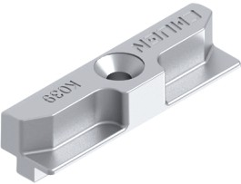 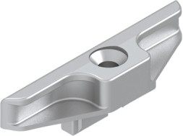 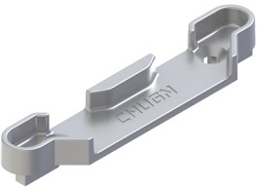

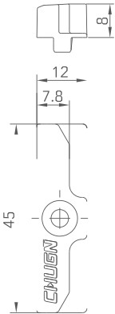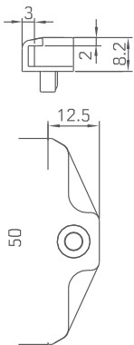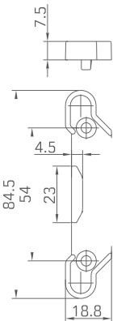

|  |  |
| --- | --- |
| ITEM NO. | CGK061 |
| TEXTURES | ZINC |

|  |  |
| --- | --- |
| ITEM NO. | CGK065 |
| TEXTURES | ZINC |

|  |  |
| --- | --- |
| ITEM NO. | CGK054 |
| TEXTURES | ZINC |

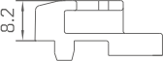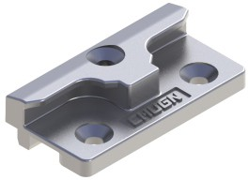

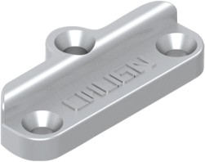8.5

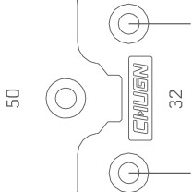

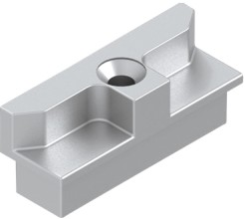-----2.:i..

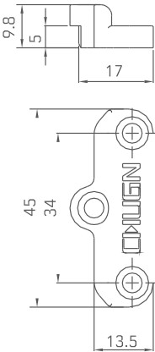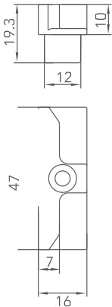

|  |  |
| --- | --- |
| ITEM NO. | CGK065B |
| TEXTURES | ZINC |

|  |  |
| --- | --- |
| ITEM NO. | CGK282 |
| TEXTURES | ZINC |

|  |  |
| --- | --- |
| ITEM NO. | CGK031 |
| TEXTURES | ZINC |

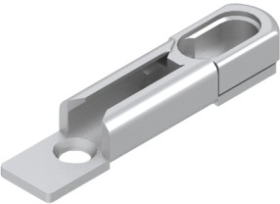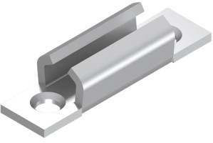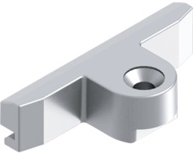*�¾*

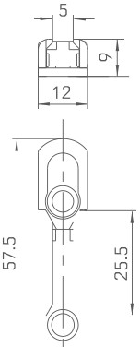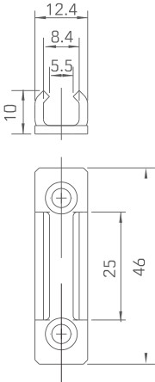

*�*

,7-@1

*£*

|  |  |
| --- | --- |
| ITEM NO. | CGK039 |
| TEXTURES | ZINC |

|  |  |
| --- | --- |
| ITEM NO. | CGK028 |
| TEXTURES | ZINC |

|  |  |
| --- | --- |
| ITEM NO. | CGK040B |
| TEXTURES | ZINC |

|  |  |
| --- | --- |
| ITEM NO. | CGK038A |
| TEXTURES | ZINC |

|  |  |
| --- | --- |
| ITEM NO. | CGK036 |
| TEXTURES | CARBON STEEL&ZINC |

|  |  |
| --- | --- |
| ITEM NO. | CGK023 |
| TEXTURES | CARBON STEEL |

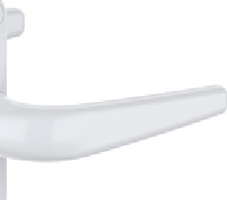

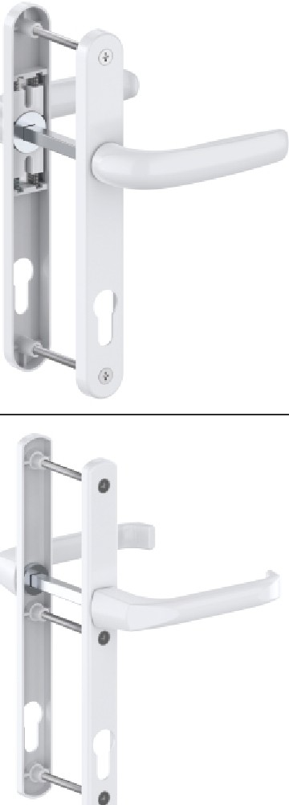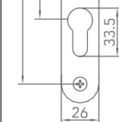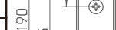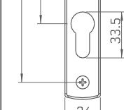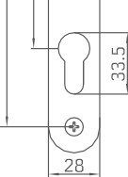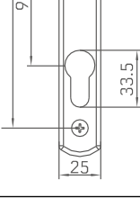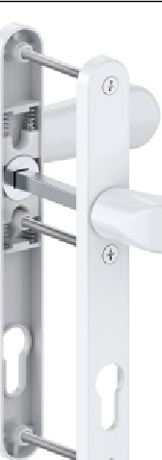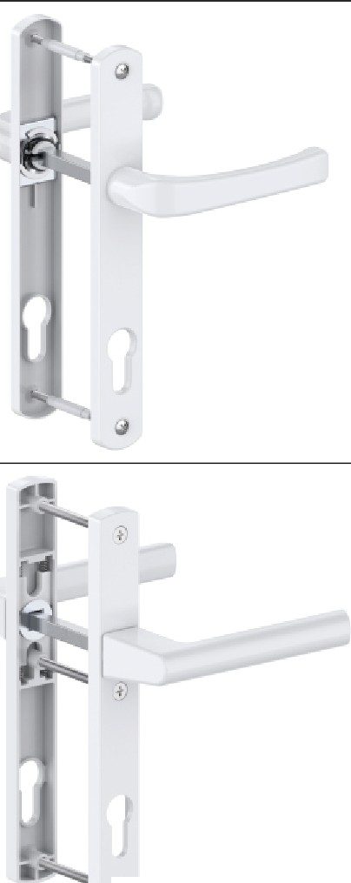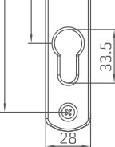

IBm

T

�,m

IBm

IBrn

[ "..

�,m

i'

1---------I----

30 SETS/CTN

PACKAGING

L1=T+40 L2=T+10

PARAMETER

HANDLE:ALUMINUM BASE:ZINC

MATERIAL

**CGDMS035-LS**

ITEM NO.

30 SETS/CTN

PACKAGING

L1=T+55 L2=35/50

WHEN T?,55, CHOOSE L2=50

PARAMETER

HANDLE:ALUMINUM BASE:CARBON STEEL

MATERIAL

**CGDMS8525-LS**

ITEM NO.

30 SETS/CTN

PACKAGING

L1=T+45 L2=T+10

PARAMETER

HANDLE:ALUMINUM BASE:ZINC

MATERIAL

**CGDMS033O-LS**

ITEM NO.

30 SETS/CTN

PACKAGING

L1=T+30 L2=T+10

PARAMETER

HANDLE:ALUMINUM BASE:ALUMINUM

MATERIAL

**CGDMS030B-LS**

ITEM NO.

30 SETS/CTN

PACKAGING

L1=T+30 L2=T+10

PARAMETER

HANDLE:ALUMINUM BASE:ALUMINUM

MATERIAL

**CGDMS029-LS**

ITEM NO.

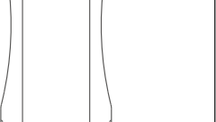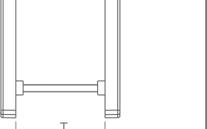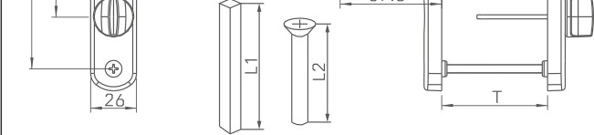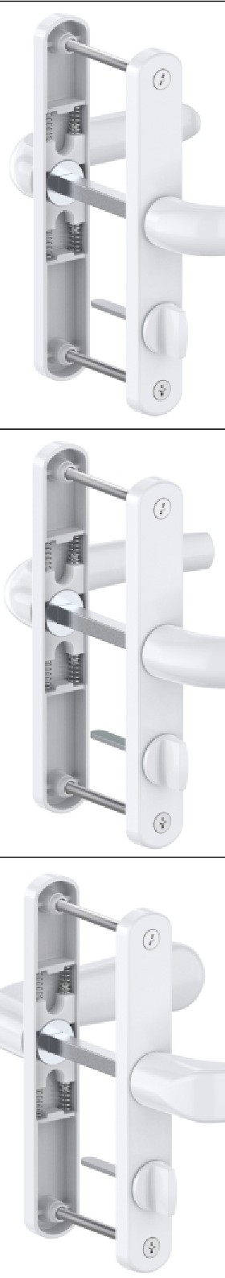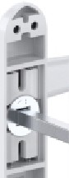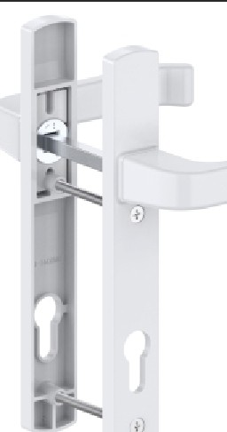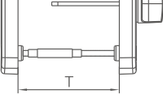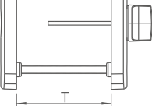

129

IBm

IBrn

�,rn

IBrn

20 SETS/CTN

PACKAGING

L1=T+45 L2=T+10

PARAMETER

HANDLE:ALUMINUM BASE:ALUMINUM

MATERIAL

CGDMS5030F-LS

ITEM NO.

20 SETS/CTN

PACKAGING

L1=T+45 L2=T+10

PARAMETER

HANDLE:ALUMINUM BASE:ALUMINUM

MATERIAL

**CGDMS5030C-LS**

ITEM NO.

20 SETS/CTN

PACKAGING

L1=T+25 L2=35150

WHEN T?,55, CHOOSE L2=50

PARAMETER

HANDLE:ALUMINUM BASE:ALUMINUM

MATERIAL

**CGDMS5025-LS**

ITEM NO.

20 SETS/CTN

PACKAGING

L1=T+40 L2=T+10

PARAMETER

HANDLE:ALUMINUM BASE:ALUMINUM

MATERIAL

**CGDMS041-LS**

ITEM NO.

12 SETS/CTN

PACKAGING

L1=T+30 L2=ST4.2X13

PARAMETER

HANDLE:ALUMINUM BASE:ALUMINUM

MATERIAL

:;

**CGDMS040-LS**

ITEM NO.

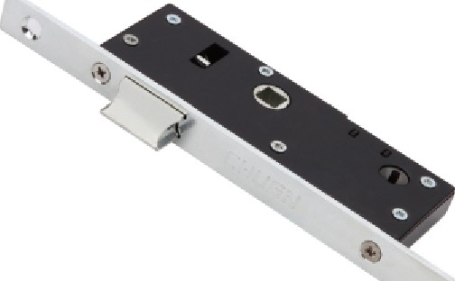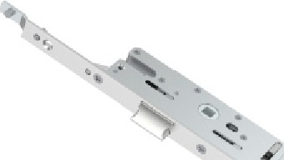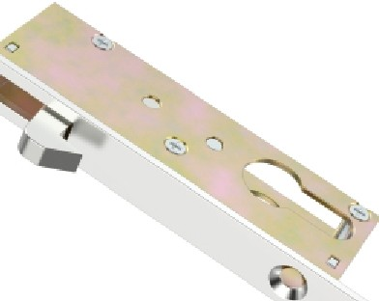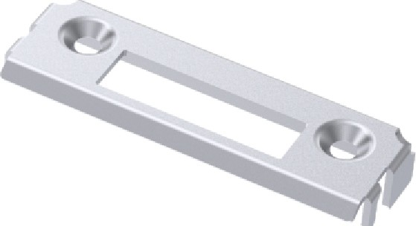

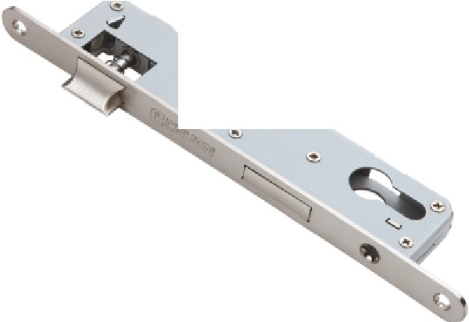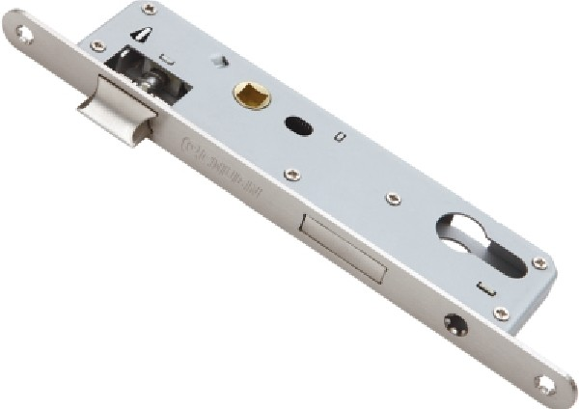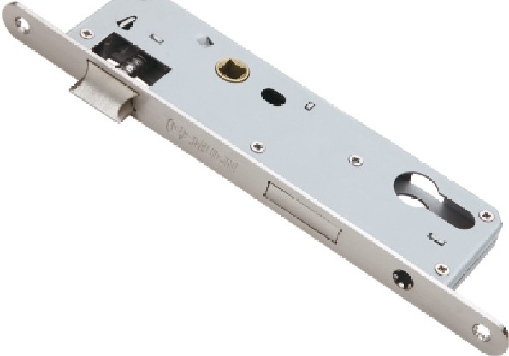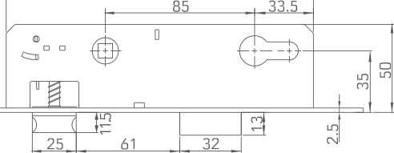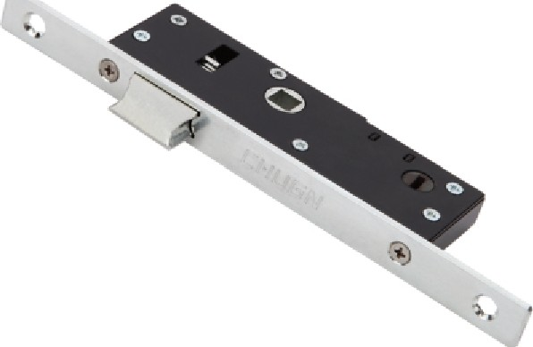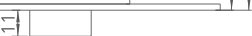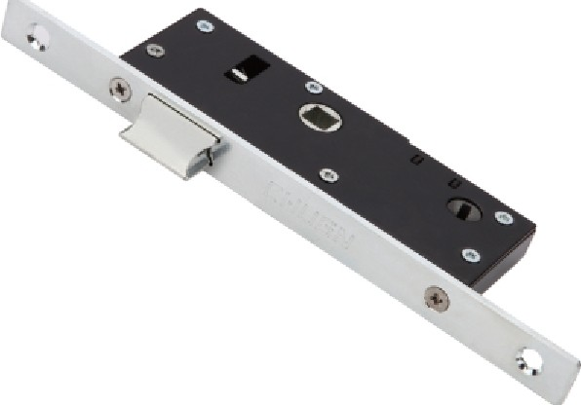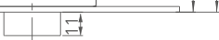

ITEM NO.

•

**CGST8525-S**

MATERIAL PANEL, STAINLESS STEEL

BASE, CARBON STEEL

230

-=

**21**

□

"''

PACKAGING

20 PCS/CTN

�

[ *k* ***•:, b***�***,***

c!ih

00

~~0:~~

ITEM NO.

**CGST8530-S**

MATERIAL

PANEL, STAINLESS STEEL BASE, CARBON STEEL

230

PACKAGING 20 PCS/CTN

�t CQ!-=

210

[ **00**

**O**

ol

'."•:fO,�

�h

..

ITEM NO.

-

MATERIAL

**CGST8535-S**

PANEL, STAINLESS STEEL BASE, CARBON STEEL

230

9

PACKAGING 20 PCS/CTN

«§

- =

**210**

c!ih

175

0lW

ITEM NO.

MATERIAL

**CGST5025-S**

PANEL, STAINLESS STEEL BASE, CARBON STEEL

**;a**

PACKAGING 50 PCS/CTN

I @I

®  *li:/1/JJilml* c::]®

@I I

122

*(I)®*□□

,j)

*(I)*

�

ITEM NO. **CGST5030-S**

MATERIAL PANEL, STAINLESS STEEL

BASE, CARBON STEEL

���

PACKAGING

50 PCS/CTN

I I

@

®

*li:1H1fill/i1/*

c::]®

@

I I

122

*(I)®*□□

*(I)*

*(I)*

Q

10

**17.5** 50

**17.5** 50

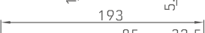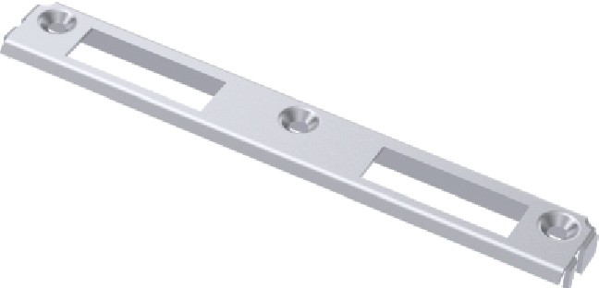

ITEM NO.

195

**170**

MATERIAL

I I©

® *li:/1/JJilml* c::]®

@I I

PACKAGING

122

�

*.*

ITEM NO.

LJJ

**397.1**

.£

tO

MATERIAL

PACKAGING

**14.5**

- -

�

•:<"

'·•

ITEM NO.

**CGST9820-S**

I<¥

1 140

MATERIAL PANEL, CARBON STEEL

BASE, CARBON STEEL

Ju§f

,20

I

***tr,***

PACKAGING

60 PCS/CTN

..

98

**12.5**

ro

:::

C

lHJ

ITEM NO.

**DMS6325-06**

MATERIAL CARBON STEEL

�

1

PACKAGING 200 PCS/CTN

ri

:::!

�!

1n

ITEM NO.

**MSK9**

MATERIAL STAINLESS STEEL

42 4j 42

PACKAGING 200 PCS/CTN

��CTI

01

@

I�

**1**

20 PCS/CTN

PANEL, CARBON STEEL BASE, CARBON STEEL

**CGST30-S**

50 PCS/CTN

PANEL, STAINLESS STEEL BASE, CARBON STEEL

**CGST5035-S**

|  |  |  |
| --- | --- | --- |
| 17. 50 | |  |
| *(I)®*□□  *(I) (I)* |  |  |
|  |  |

|  |  |  |  |
| --- | --- | --- | --- |
| C  A | ITEM NO. | CGSX001 |  |
| MATERIAL | COPPER |
| PACKAGING | 60 PCS/CTN |
|  | |
| -�-- �+�T*r*I | ITEM NO. | CGSX001B |  |
| MATERIAL | COPPER |
| PACKAGING | 60 PCS/CTN |
|  | |
| W I | ITEM NO. | CGSX002 |  |
| MATERIAL | COPPER |
| PACKAGING | 60 PCS/CTN |
|  | |

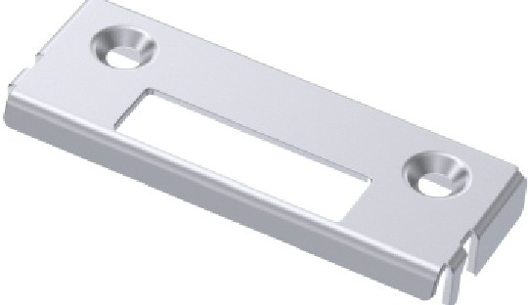LOCK CORE INSTRUCTION

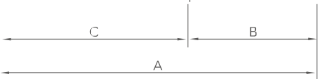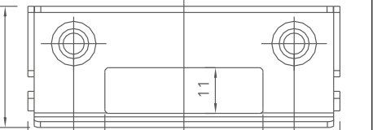

|  |  |
| --- | --- |
| ITEM NO. | **MSK25** |
| MATERIAL | CARBON STEEL |
| PACKAGING | 200 PCS/CTN |

|  |  |  |  |
| --- | --- | --- | --- |
|  | ITEM NO. | MSK98 | 1,tITI 42 ; 42 I�  I I al |
| MATERIAL | CARBON STEEL |
| PACKAGING | 200 PCS/CTN |
|  | |
|  | ITEM NO. | MSK12 |  |
| MATERIAL | CARBON STEEL |
| PACKAGING | 200 PCS/CTN |
|  | |
|  | ITEM NO. | MSK24 |  |
| MATERIAL | CARBON STEEL |
|  |
| PACKAGING | 200 PCS/CTN |
|  | |
|  | | | 14 |
| N  ?i  � 38  53  75 |

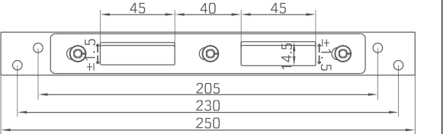

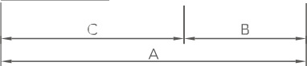

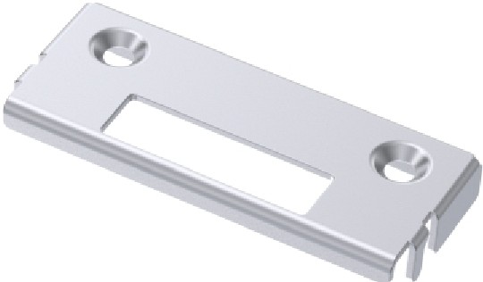1 1

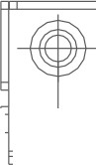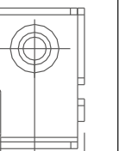

38

53

;::

ITEM NO.

**MSK26**

MATERIAL CARBON STEEL

PACKAGING 200 PCS/CTN

1{

I 75

CYLINDER SPECIFICATION

|  |  |  |
| --- | --- | --- |
| A | B | C |
| 70 | 30 | 40 |
| 75 | 30 | 45 |
| 75 | 42.5 | 32.5 |
| 80 | 30 | 50 |
| 85 | 55 | 30 |

PLEASE SELECT THE SPECIFICATIONS OF THE LOCK CORE ACCORDING TO THE DIAGRAM ON THE LEFT

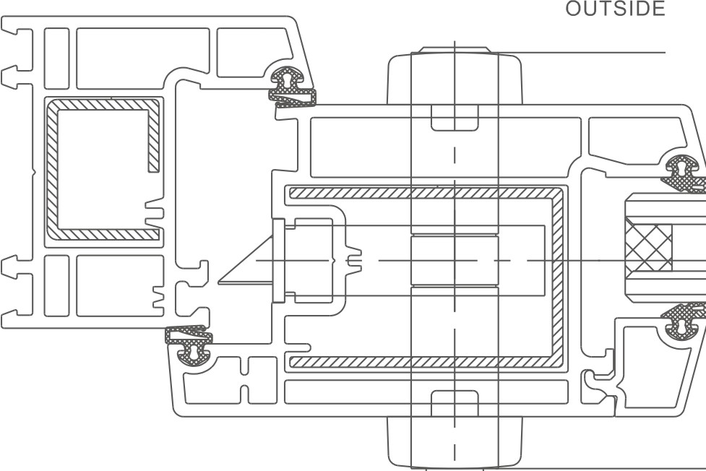

u

CD

INSIDE

A=TOTAL LENGTH OF CYLINDER

B=DISTANCE FROM THE KNOB TO CYLINDER CENTER C=DISTANCE FROM THE KEY TO CYLINDER CENTER

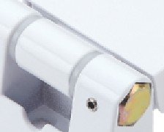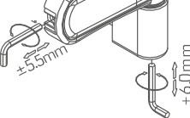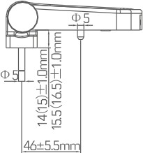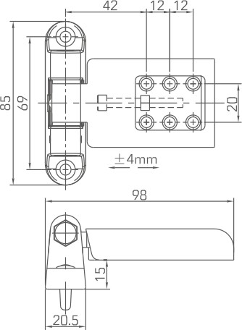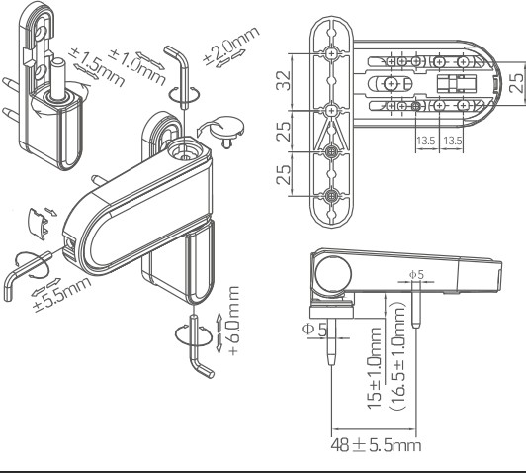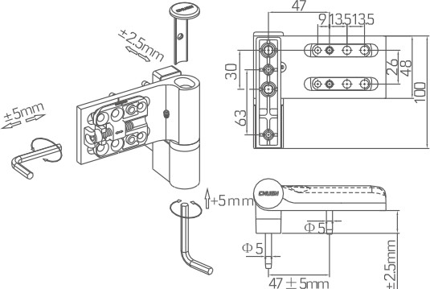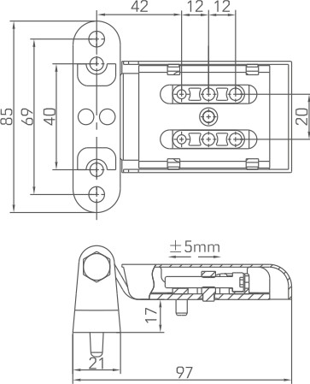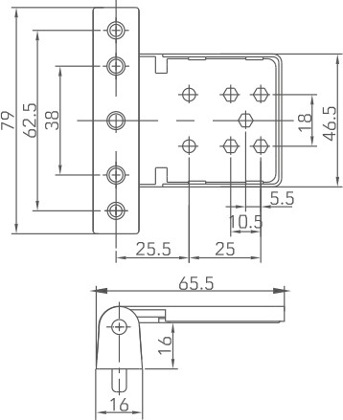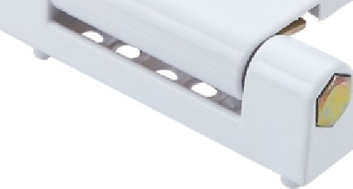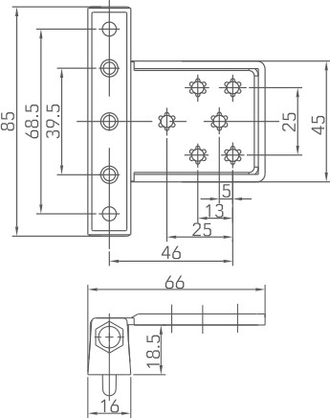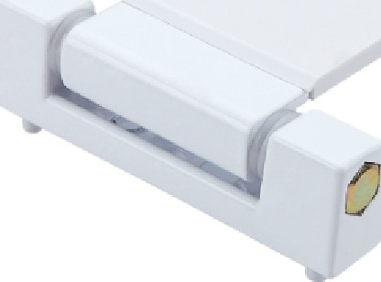

|  |  |  |  |  |  |  |  |
| --- | --- | --- | --- | --- | --- | --- | --- |
| ) | | ITEM NO. | CGJL3D-90 |  | | | |
| MATERIAL | ZINC |
| BEARING | 90 KG/2PCS |
| PACKAGING | 30 PCS/CTN |
|  | |
|  | | ITEM NO. | CGJL3D-S-105 |  | �¾;i\;;; *�1-<t:"'* al�  *!O* uW  I) | | UL! |
| MATERIAL | ZINC |
| BEARING | 90 KG/2PCS |
| PACKAGING | 30 PCS/CTN |
|  | |
|  | | ITEM NO. | CGJL003-S-108 |  |  |  | |
| MATERIAL | ZINC |
| BEARING | 120 KG/2PCS |
| PACKAGING | 30 PCS/CTN |
|  | |
| *(* | ***r*** | ITEM NO. | **CGPMJ3DB-S** |  |
| MATERIAL | ALUMINUM |
| BEARING | 90 KG/2PCS |
| PACKAGING | 30 PCS/CTN |
|  | |
|  | | ITEM NO. | **CGJL024-S** | F---1L | | | |
| MATERIAL | ALUMINUM |
| BEARING | 80 KG/2PCS |
| PACKAGING | 50 PCS/CTN |
|  | |

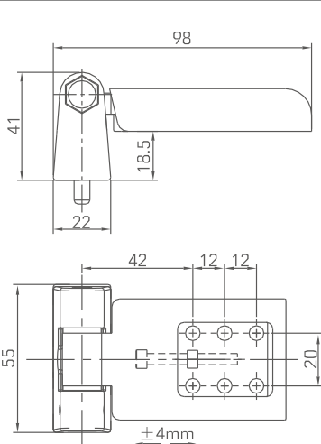

ITEM NO.

MATERIAL

CGJL001-S

ALUMINUM

BEARING

60 KG/2PCS

PACKAGING 100 PCS/CTN

ITEM NO.

MATERIAL

CGJL002-S

ALUMINUM

BEARING

60 KG/2PCS

PACKAGING 50 PCS/CTN

ITEM NO.

MATERIAL

CGJL002B-S

ALUMINUM

BEARING

70 KG/2PCS

PACKAGING 50 PCS/CTN

ITEM NO.

MATERIAL

CGJL005-S

ALUMINUM

BEARING

60 KG/2PCS

PACKAGING 200 PCS/CTN

ITEM NO.

MATERIAL

CGJL005B-S

ALUMINUM

BEARING

60 KG/2PCS

PACKAGING 200 PCS/CTN

*(*

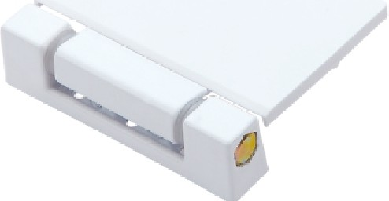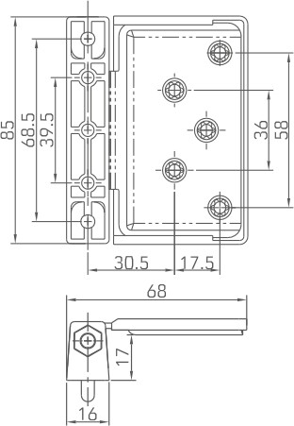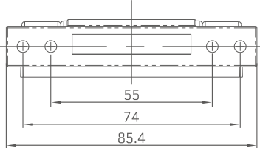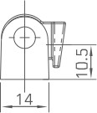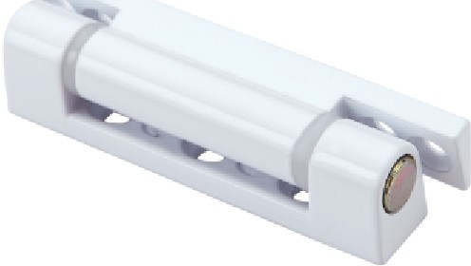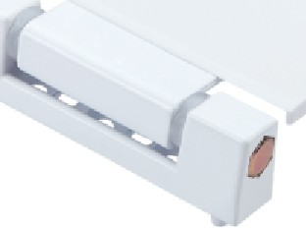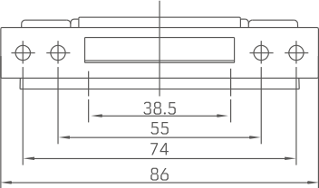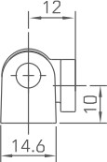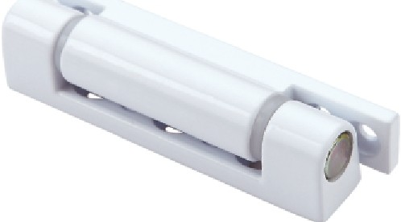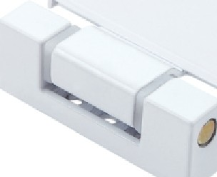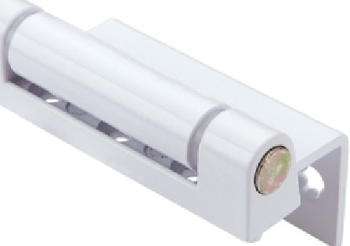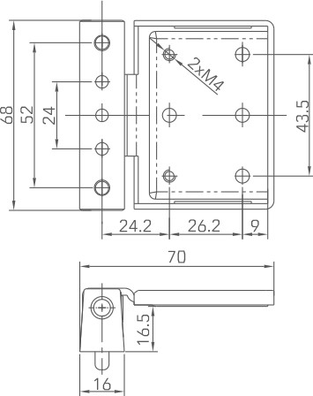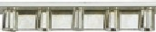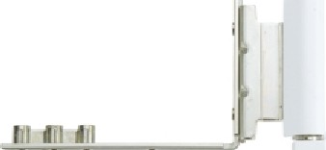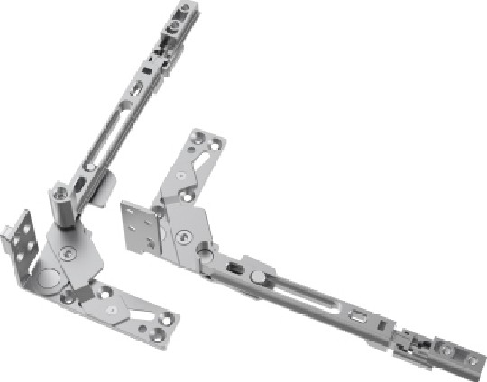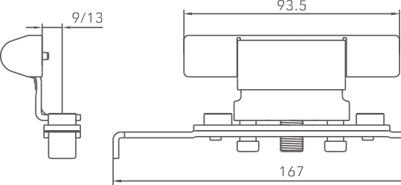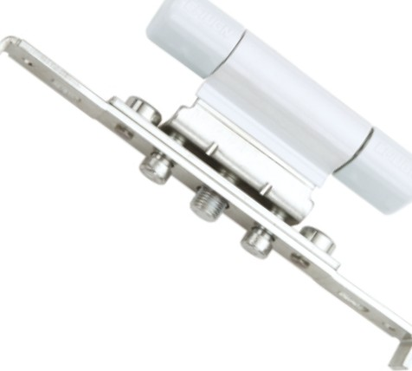

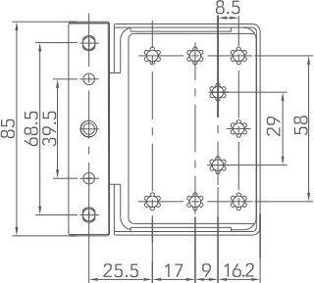

FLlliJ

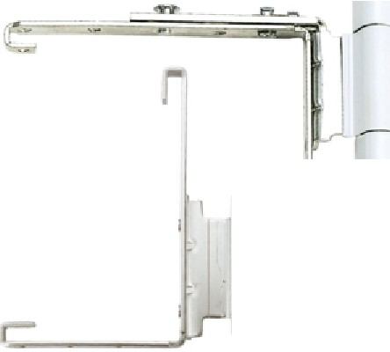

u

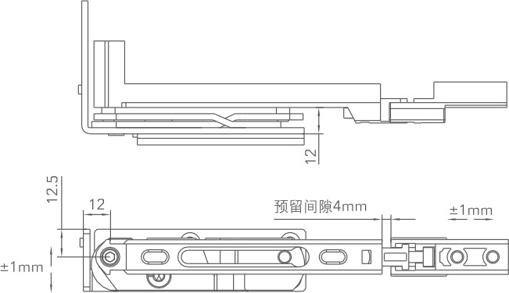

02mm:

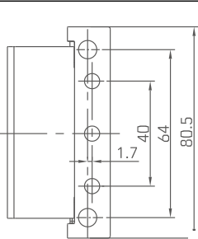

ITEM NO.

MATERIAL

CGJL006B-S

ALUMINUM

BEARING

60 KG/2PCS

PACKAGING 100 PCS/CTN

ITEM NO.

MATERIAL

CGJL012B-S

ALUMINUM

BEARING

60 KG/2PCS

PACKAGING 100 PCS/CTN

ITEM NO.

MATERIAL

CGJL013-S

ALUMINUM

BEARING

40 KG/2PCS

PACKAGING 150 PCS/CTN

ITEM NO.

MATERIAL

CGJL015-S

ALUMINUM

BEARING

40 KG/2PCS

PACKAGING 150 PCS/CTN

�

�

tfilF

ITEM NO.

SYJ02-9/13

L R

MATERIAL STAINLESS STEEL&ZINC

BEARING

60 KG/2PCS

PACKAGING 40 PCS/CTN

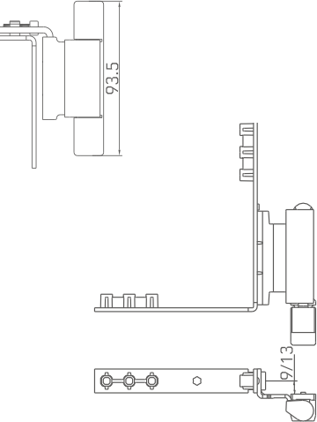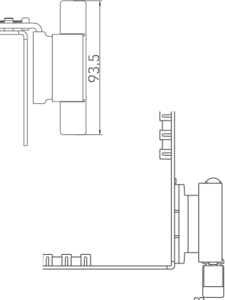

ITEM NO.

MATERIAL

CGJL019A-S

ZINC

BEARING

40 KG/2PCS

PACKAGING 100 PCS/CTN

ITEM NO.

MATERIAL

CGJL019B-S

ZINC

BEARING

40 KG/2PCS

PACKAGING 200 PCS/CTN

ITEM NO.

CGJL020-S-9/13

L R

lllLILlllLITilD

MATERIAL

CARBON STEEL

BEARING

90 KG/2PCS

PACKAGING 40 SETS/CTN

7

**100000[@** CID�

ITEM NO.

CGJL020-S-B-9/13 �

lllLILlllLITilD

MATERIAL

CARBON STEEL

BEARING

90 KG/2PCS

PACKAGING 40 SETS/CTN

100000(@ CID�

�

ITEM NO.

MATERIAL

CGJL020SB-03

CARBON STEEL&ZINC

BEARING

PACKAGING 100 PCS/CTN

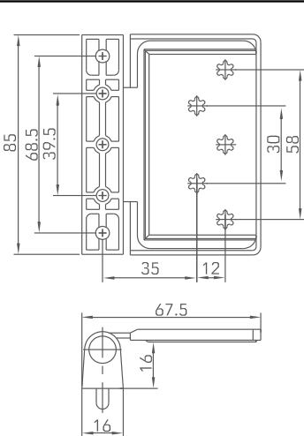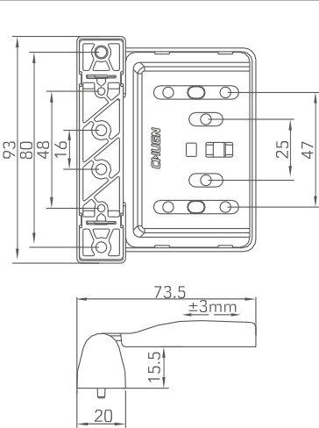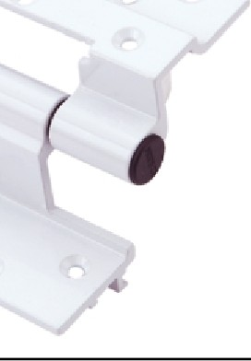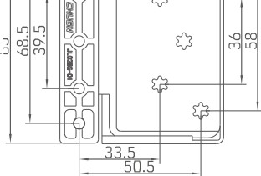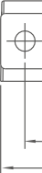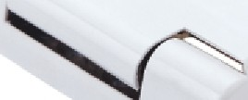

100

*(*

40

70

qf

ITEM NO.

CGJL028-S

MATERIAL BEARING

PACKAGING

�

ITEM NO.

CGJL075-S

MATERIAL

ZINC

BEARING

40 KG/2PCS

PACKAGING 200 PCS/CTN

42

63.5

75

I

*�*

I

100 PCS/CTN

60 KG/2PCS

CARBON STEEL&ALUMINUM

80 PCS/CTN

PACKAGING

70 KG/2PCS

BEARING

CARBON STEEL&ZINC

MATERIAL

CGJL027C-S

ITEM NO.

80 PCS/CTN

PACKAGING

70 KG/2PCS

BEARING

CARBON STEEL&ZINC

MATERIAL

CGJL025-S

ITEM NO.

100 PCS/CTN

PACKAGING

60 KG/2PCS

BEARING

CARBON STEEL&ALUMINUM

MATERIAL

CGJL023-S

ITEM NO.

ITEM NO.

CGJL080-S

MATERIAL

ZINC

BEARING

40 KG/2PCS

PACKAGING 100 PCS/CTN

*(*

ITEM NO.

MATERIAL

CGJL100-S

ZINC

BEARING

40 KG/2PCS

-

PACKAGING 100 PCS/CTN

ITEM NO.

MATERIAL

CGJL100B-S

ZINC

BEARING

40 KG/2PCS

PACKAGING 100 SETS/CTN

ITEM NO.

CGJL038-S

70

MATERIAL

ALUMINUM

BEARING

60 KG/2PCS

*(*

PACKAGING 100 PCS/CTN

�

21

ITEM NO.

80

40

MATERIAL

CGJL039-S

ALUMINUM

BEARING

60 KG/2PCS

*(*

0

0

0

*(*

0

PACKAGING

70 PCS/CTN

0

0

0

�

24

103

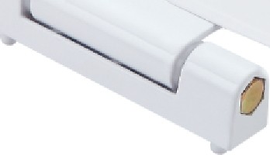 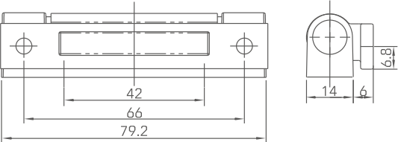 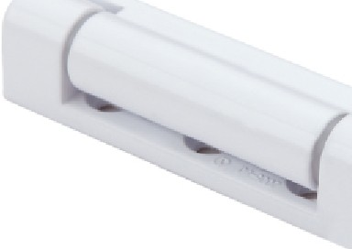

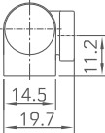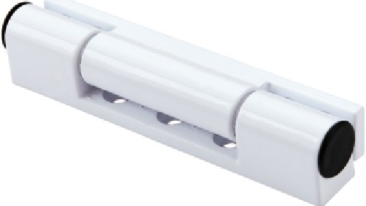

|  |
| --- |
| -Ell-/4,-1 I I-Ell-/4, |
| I I i 36 I I I  61  83 |
| 99.5 |

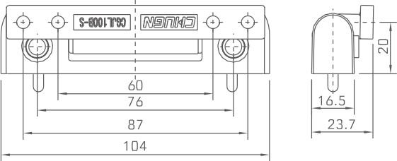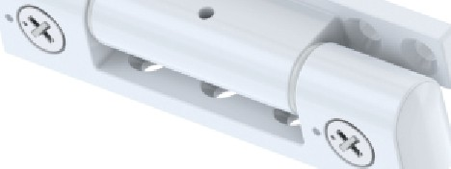

|  |
| --- |
|  |
|  |
| 0 0 0 |
| 0 |



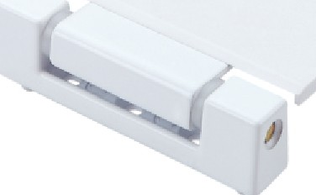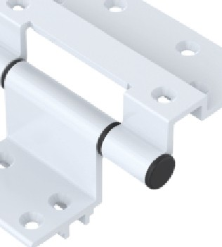

|  |  |  |
| --- | --- | --- |
|  | 35 |  |
|  |
|  |  |  |
|  | | |
|  | | |
| 0 0 | | |
|  | | |

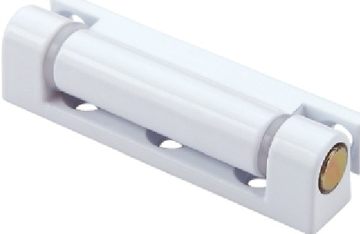

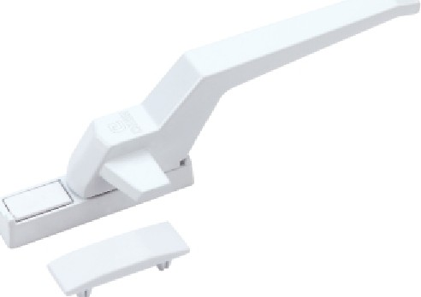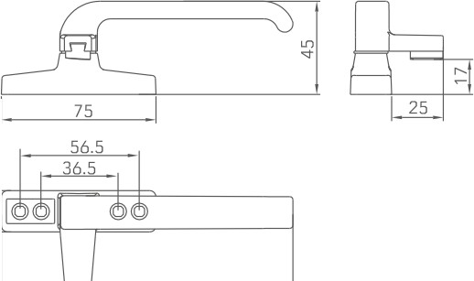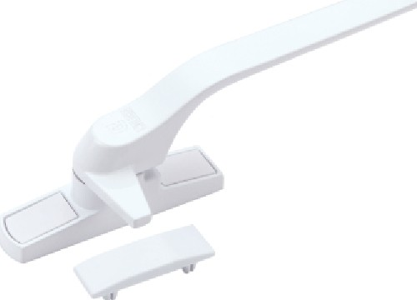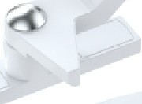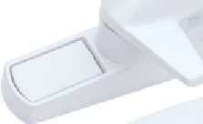

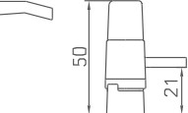

,ng

l+I

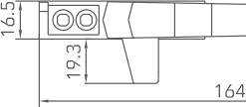

ITEM NO.

MATERIAL HANDLE:ALUMINUM

BASE:ZINC

PACKAGING 200 PCS/CTN

�

�ffi

tcffi

�

7

150

ITEM NO.

L

R

MATERIAL

CGZS003-SG

HANDLE:ZINC BASE:ZINC

PACKAGING 100 PCS/CTN

�{�

1jlvl

ll7rll

147

ITEM NO.

CGZS004-SG

HANDLE:ALUMINUM BASE:ZINC

L

R

MATERIAL

200 PCS/CTN

�

�

'� N

PACKAGING

' (

)1

140

ITEM NO.

MATERIAL

CGZS006-SG

HANDLE:ZINC BASE:ZINC

L

R

PACKAGING 200 PCS/CTN

;[&

�,1,_uI

11 11

150

L

R

CGZS002-SG

100 PCS/CTN

PACKAGING

HANDLE:ALUMINUM BASE:ZINC

MATERIAL

L R

CGZS001-SG

ITEM NO.

|  |  |  |  |
| --- | --- | --- | --- |
| I 141 | ITEM NO. | CGZS007-SG L  R |  |
| MATERIAL | HANDLE:ALUMINUM BASE:ALUMINUM |
| PACKAGING | 100 PCS/CTN |
|  | |
| 68 | ITEM NO. | CGYY015-LS |  |
| MATERIAL | HANDLE:ALUMINUM BASE:ALUMINUM |
| PACKAGING | 200 PCS/CTN |
|  | |

tE

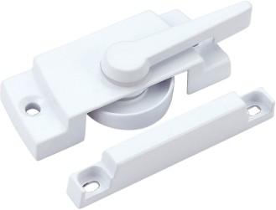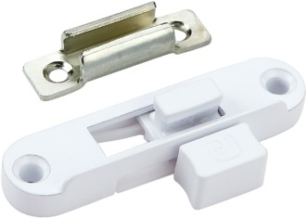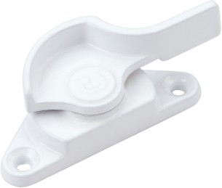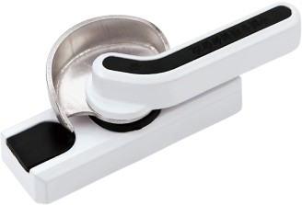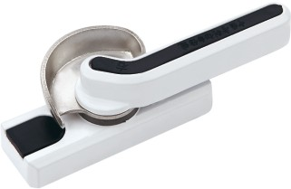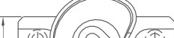

C

N

�

N

62.5

� � 1

1

�

�

D

J

�

N

�

�

91.5

i

200 PCS/CTN

PACKAGING

HANDLE:ZINC BASE:ZINC

MATERIAL

CGYY017-LS

ITEM NO.

200 PCS/CTN

PACKAGING

HANDLE:ZINC BASE:ALUMINUM

MATERIAL

CGYY016-LS

ITEM NO.

1

66.5

I..J..LI

7,1&

79.5

11

r d I

200 PCS/CTN

PACKAGING

HANDLE:ZINC BASE:ZINC

MATERIAL

CGYY013-LS

ITEM NO.

�

65

�

�E32.5 m

c �

i��

53

200 PCS/CTN

PACKAGING

HANDLE:ZINC BASE:ZINC

MATERIAL

CGYY009-LS

ITEM NO.

200 PCS/CTN

PACKAGING

HANDLE:ZINC BASE:ZINC

MATERIAL

CGYY007-LS

ITEM NO.

|  |  |  |  |  |
| --- | --- | --- | --- | --- |
|  | ITEM NO. | CGYY001-LS | tE | '�  � Az18, 21  9 *(* T�T_:;  141 |
| MATERIAL | HANDLE:ZINC BASE:ZINC | |
| PACKAGING | 100 PCS/CTN | |
| tE | | |
|  | ITEM NO. | CGYY002-LS |  | ���  l 99 _j A-18. 21  � 112 |
| MATERIAL | HANDLE:ZINC BASE:ZINC | |
| PACKAGING | 100 PCS/CTN | |
| tE | | |
|  | ITEM NO. | CGYY003-LS |  | ���  �, 65.5 J  47 f j  105 |
| MATERIAL | HANDLE:ZINC BASE:ZINC | |
| PACKAGING | 100 PCS/CTN | |
| tE | | |
|  | ITEM NO. | CGYY004-LS |  | �,rT1 7S, $ N  :  �  91.5 J |
| MATERIAL | HANDLE:ZINC BASE:ZINC | |
| PACKAGING | 200 PCS/CTN | |
| tE | | |
|  | ITEM NO. | CGYY005-LS |  | 4t· ��  � 625 7  {  46:-4  81 |
| MATERIAL | HANDLE:ZINC BASE:ZINC | |
| PACKAGING | 200 PCS/CTN | |
|  | | |

tE

tE



tE



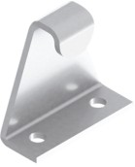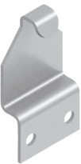 b 6

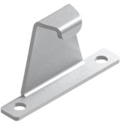

Jrn

T **38.5**

14'- 111 -$ I

I

30

I

\

2_7_

�

�

v

,-$-

-$-

L-25, 27

� �

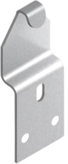**L-23. 25,** 27. 29

ll_,l

11�� I

#

--

!

-�

a

-014-J[�

|  |  |
| --- | --- |
| ITEM NO. | **CGYG018** |
| TEXTURES | CARBON STEEL  OR STAINLESS STEEL |

|  |  |
| --- | --- |
| ITEM NO. | **CGYG004** |
| TEXTURES | CARBON STEEL  OR STAINLESS STEEL |

|  |  |
| --- | --- |
| ITEM NO. | **CGYG010** |
| TEXTURES | STAINLESS STEEL |

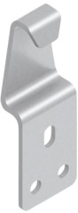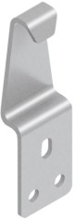�9"�

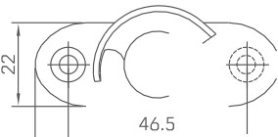

* f�

~~l�I~~  �

|  |  |
| --- | --- |
| ITEM NO. | **CGYG009A** |
| TEXTURES | CARBONSTEEL |

|  |  |
| --- | --- |
| ITEM NO. | **CGYG009** |
| TEXTURES | CARBONSTEEL |

,i/1·�

:;;

|  |  |
| --- | --- |
| ITEM NO. | **CGYG016O** |
| TEXTURES | STAINLESS STEEL |

iifl ,]

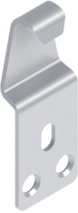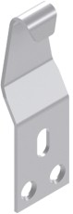-

1

_1_9_

::i

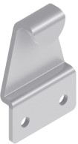5

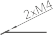

i

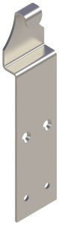a- - �

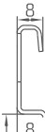

g: +

*'G*

l

�

. .

� JL

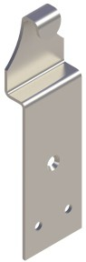Ji

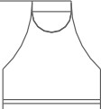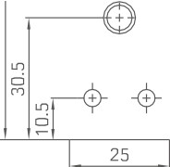

:ii

|  |  |  |  |  |
| --- | --- | --- | --- | --- |
|  | ITEM NO. | **CGYY021-LS** EE |  | J &t3  �  ,1� I  78 |
| MATERIAL | HANDLE:ZINC BASE:ZINC | |
| PACKAGING | 200 PCS/CTN | |
| EE | | |
|  | ITEM NO. | **CGYY022-LS** |  | · J vL�  N  �  78 |
| MATERIAL | HANDLE:ZINC BASE:ZINC | |
| PACKAGING | 200 PCS/CTN | |
| ITEM NO. **CGBS013-LS** EE | | |
|  |  |  |  | 100 b ffi  o  i 111 I I if  130  145 |
| MATERIAL | HANDLE:ZINC BASE:ZINC | |
| PACKAGING | 100 PCS/CTN | |
| EE | | |
|  | ITEM NO. | **CGBS013B-LS** |  | 100 bffi  0  rr :!II I 1111111111111111 f?  130  145 |
| MATERIAL | HANDLE:ALUMINUM BASE:ALUMINUM | |
| PACKAGING | 200 PCS/CTN | |
|  | | |
|  | ITEM NO. | **CGTY013** | | Jc **162.5** l  **140**  = uJ  '-=  w--l m *�B*  LmM � « »*t)* |
| MATERIAL | BASE:ALUMINUM SLIDING PARTS:PLASTIC | |
| PACKAGING | 200 PCS/CTN | |
|  | | |



|  |  |
| --- | --- |
| ITEM NO. | **CGYG016** |
| TEXTURES | STAINLESS STEEL |

|  |  |
| --- | --- |
| ITEM NO. | **CGYG033** |
| TEXTURES | STAINLESS STEEL |

|  |  |
| --- | --- |
| ITEM NO. | **CGYG034** |
| TEXTURES | STAINLESS STEEL |

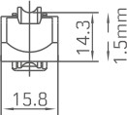

|  |  |  |  |
| --- | --- | --- | --- |
|  | ITEM NO. | CGHL001-88 | +clt11tt1  I 58.5 I |
| MATERIAL | ZINC |
| BEARING | 60 KG/2PCS |
| PACKAGING | 300 PCS/CTN |
|  | |
|  | ITEM NO. | CGHL002-88 | 70 |
| MATERIAL | ZINC |
| BEARING | 60 KG/2PCS |
| PACKAGING | 300 PCS/CTN |
|  | |
|  | ITEM NO. | CGHL003-88 | Cf?J  iffli  I 455 I |
| MATERIAL | ZINC |
| BEARING | 40 KG/2PCS |
| PACKAGING | 300 PCS/CTN |
|  | |
|  | ITEM NO. | CGHL004-88 | 58  -fi++--11---+I+iI J-  I 45.5 I |
| MATERIAL | ZINC |
| BEARING | 40 KG/2PCS |
| PACKAGING | 500 PCS/CTN |
|  | |
|  | ITEM NO. | CGHL005-95 | F±l er  iffli  I 45.5 I |
| MATERIAL | ZINC |
| BEARING | 40 KG/2PCS |
| PACKAGING | 500 PCS/CTN |
|  | |

|  |  |  |  |
| --- | --- | --- | --- |
|  | ITEM NO. | CGHL006-95 |  |
| MATERIAL | ZINC |
| BEARING | 40 KG/2PCS |
| PACKAGING | 500 PCS/CTN |
|  | |
| !3 | ITEM NO. MATERIAL  BEARING | CGHL007-77  ZINC  40 KG/2PCS |  |
| PACKAGING | 500 PCS/CTN |
|  | |
|  | ITEM NO. | CGHL008-77 |  |
| MATERIAL | ZINC |
| BEARING | 40 KG/2PCS |
| PACKAGING | 500 PCS/CTN |
|  | |
| *d*I s  I 835 I  'I 1ji1 lij�  70 | ITEM NO. | CGHL009-88 |  |
| MATERIAL | ZINC |
| BEARING | 60 KG/2PCS |
| PACKAGING | 300 PCS/CTN |
|  | |
| r -t5g!-J �I§ I"-'  q i!]  70 | ITEM NO. MATERIAL  BEARING | CGHL010-88  ZINC  60 KG/2PCS |  |
| PACKAGING | 300 PCS/CTN |
|  | |

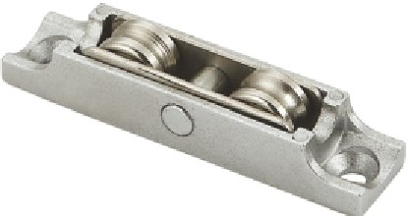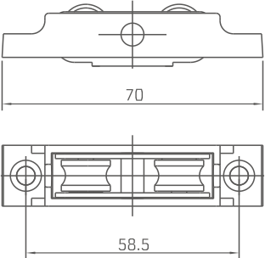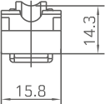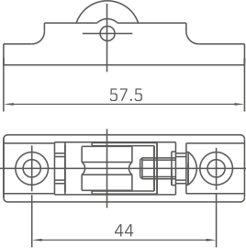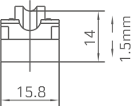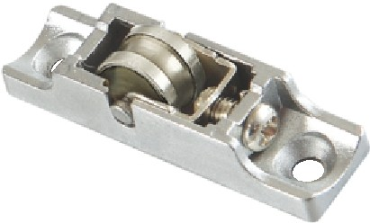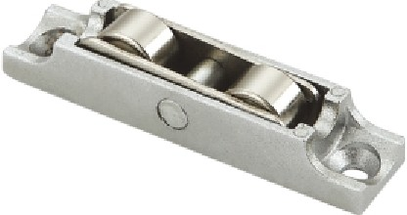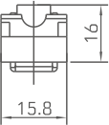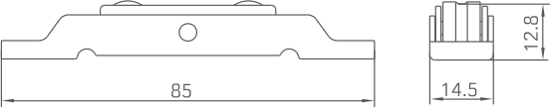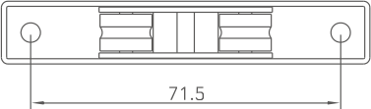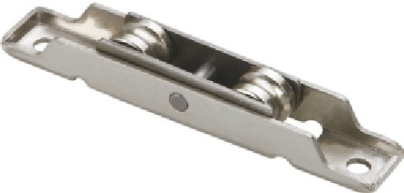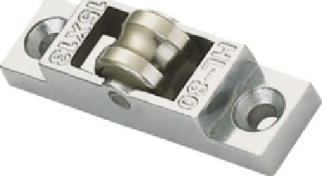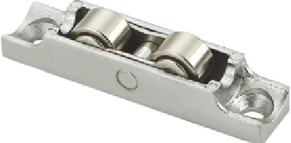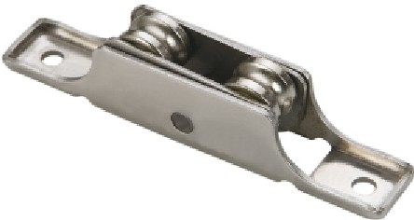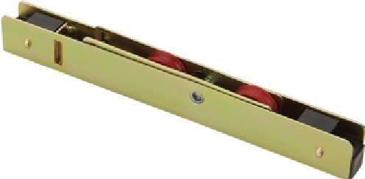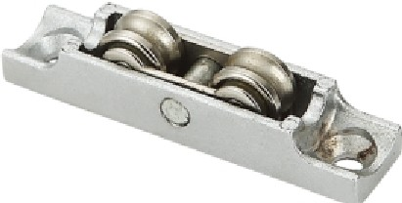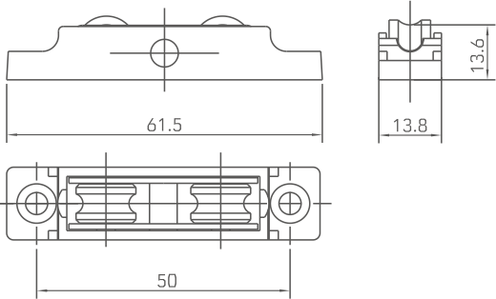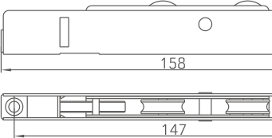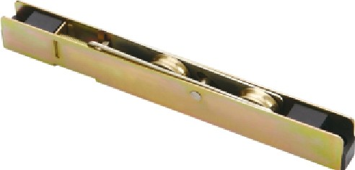

ITEM NO.

MATERIAL

CGHL013-95

ZINC

BEARING

60 KG/2PCS

PACKAGING 300 PCS/CTN

ITEM NO.

CGHL014-95

MATERIAL ZINC

BEARING

60 KG/2PCS

PACKAGING 300 PCS/CTN

c:?-t7 ½

I 70 I

1 1

I

1111 1ijl

58.s I

ITEM NO.

CGHL015-88

MATERIAL ZINC

BEARING

40 KG/2PCS

PACKAGING 500 PCS/CTN

*(12=*

m1

00

�I

ITEM NO.

MATERIAL

CGHL020-77

ZINC

BEARING

60 KG/2PCS

PACKAGING 300 PCS/CTN

I

=+= !

c!

7

61.5

I

l!a1 a,1

ITEM NO. MATERIAL

CGHL021-77

ZINC

BEARING

60 KG/2PCS

PACKAGING 300 PCS/CTN

ITEM NO.

MATERIAL

CGHL022-88

ZINC

BEARING

40 KG/2PCS

PACKAGING 500 PCS/CTN

ITEM NO.

MATERIAL

CGHL023

STAINLESS STEEL

BEARING

60 KG/2PCS

PACKAGING 300 PCS/CTN

ITEM NO.

El

= =

85 ~~�~~

I

MATERIAL

CGHL024

STAINLESS STEEL

0

BEARING

60 KG/2PCS

PACKAGING

100 PCS/CTN

[It I R !R I JI]

ITEM NO.

MATERIAL

CGHL025

CARBON STEEL

BEARING

90 KG/2PCS

D

:B0

�IE

l�

PACKAGING 100 PCS/CTN

lfl 1□□5211j::::::::j

Tl

ITEM NO.

MATERIAL

CGHL025B

CARBON STEEL

BEARING

90 KG/2PCS

PACKAGING 100 PCS/CTN

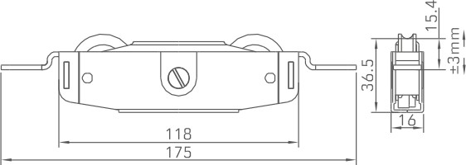

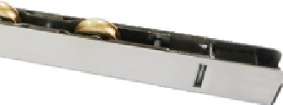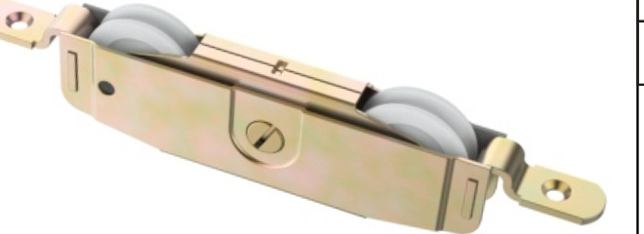

ITEM NO. CGHL025O

MATERIAL CARBON STEEL

BEARING

100 KG/2PCS

>--P_A_c_KA_G_N1_G�_1_o_o_P_c_s_,c_T_N

t::=,==O=========::::=;;::□==o===========:j

1y1 *@*□ t=:I §i 11 t=:I @ 11

E 3

150

ITEM NO. CGHL032

MATERIAL STAINLESS STEEL

BEARING

60 KG/2PCS

PACKAGING 60 PCS/CTN

71.5

ITEM NO. CGHL037-88

MATERIAL STAINLESS STEEL

BEARING

40 KG/2PCS

PACKAGING 500 PCS/CTN

c

0

= =

q

64

!:]

@5 01

a11a

51.5

p

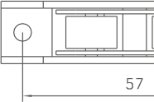

ITEM NO.

~~=~~

0

!3

MATERIAL

CGHL043-88

ALUMINUM

BEARING

40 KG/2PCS

�

55

�

PACKAGING

500 PCS/CTN

11 IRI

45

ti

11:11

ITEM NO.

MATERIAL

CGHL045-88

ALUMINUM

BEARING

60 KG/2PCS

�

PACKAGING 300 PCS/CTN

ITEM NO. CGHL046-88

MATERIAL STAINLESS STEEL

BEARING

40 KG/2PCS

PACKAGING 500 PCS/CTN

ITEM NO.

c

11

CGHL047-88

STAINLESS STEEL

0

64

=

=

!]

f

8J1

MATERIAL

BEARING 60 KG/2PCS

PACKAGING

300 PCS/CTN

1111

51.5

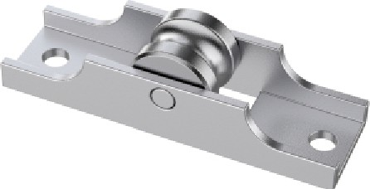

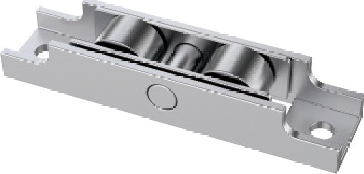

|  |  |  |  |  |  |  |
| --- | --- | --- | --- | --- | --- | --- |
| ITEM NO. | CGHL031 |  |  |  | ITEM NO. | CGHL044-88 |
| MATERIAL | CARBON STEEL |  |  |  | MATERIAL | ALUMINUM |
| BEARING | 80 KG/2PCS |  |  |  | BEARING | 60 KG/2PCS |
| PACKAGING | 100 PCS/CTN |  |  | f---E-: ,7 | PACKAGING | 300 PCS/CTN |

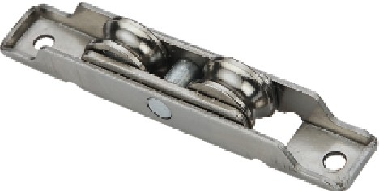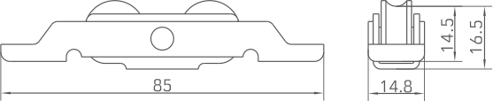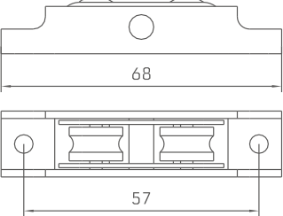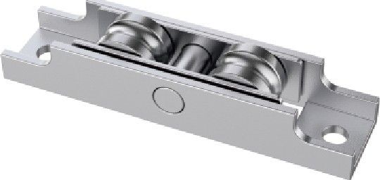

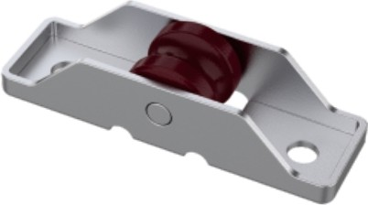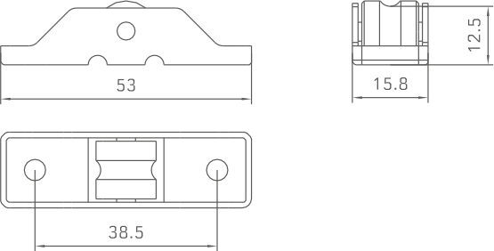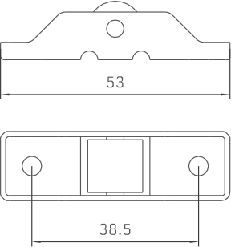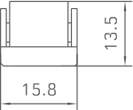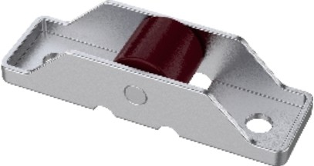

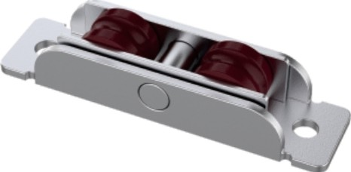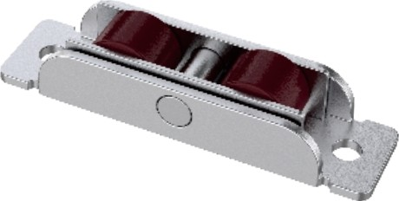

|  |  |
| --- | --- |
| ITEM NO. | CGHL038-88 |
| MATERIAL | STAINLESS STEEL |
| BEARING | 60 KG/2PCS |
| PACKAGING | 300 PCS/CTN |

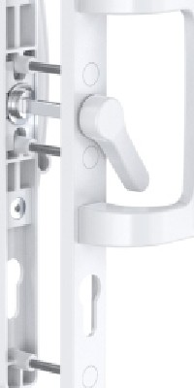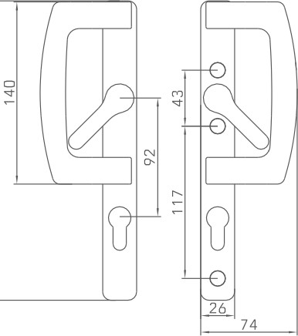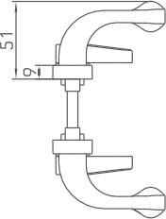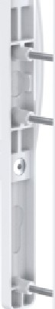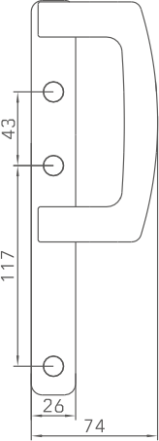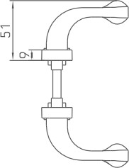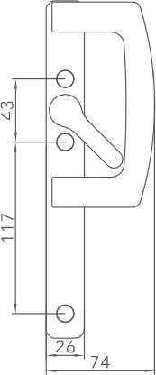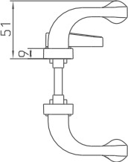

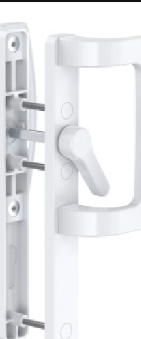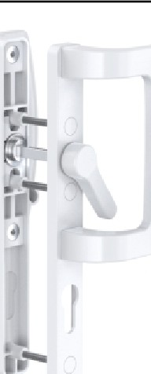

ITEM NO.

CGDMS-LS113

L R

MATERIAL

ALUMINUM

PACKAGING

20 SETS/CTN

□

M N

ITEM NO.

CGDMS-LS113B

L R

MATERIAL

ALUMINUM

PACKAGING

20 SETS/CTN

□

M N

ITEM NO.

CGDMS-LS113C

L R

MATERIAL

ALUMINUM

PACKAGING

20 SETS/CTN

ITEM NO.

CGDMS-LS113D

L R

MATERIAL

ALUMINUM

PACKAGING

20 SETS/CTN

ITEM NO.

CGDMS-LS113E

L R

MATERIAL

ALUMINUM

PACKAGING

20 SETS/CTN

□

M N

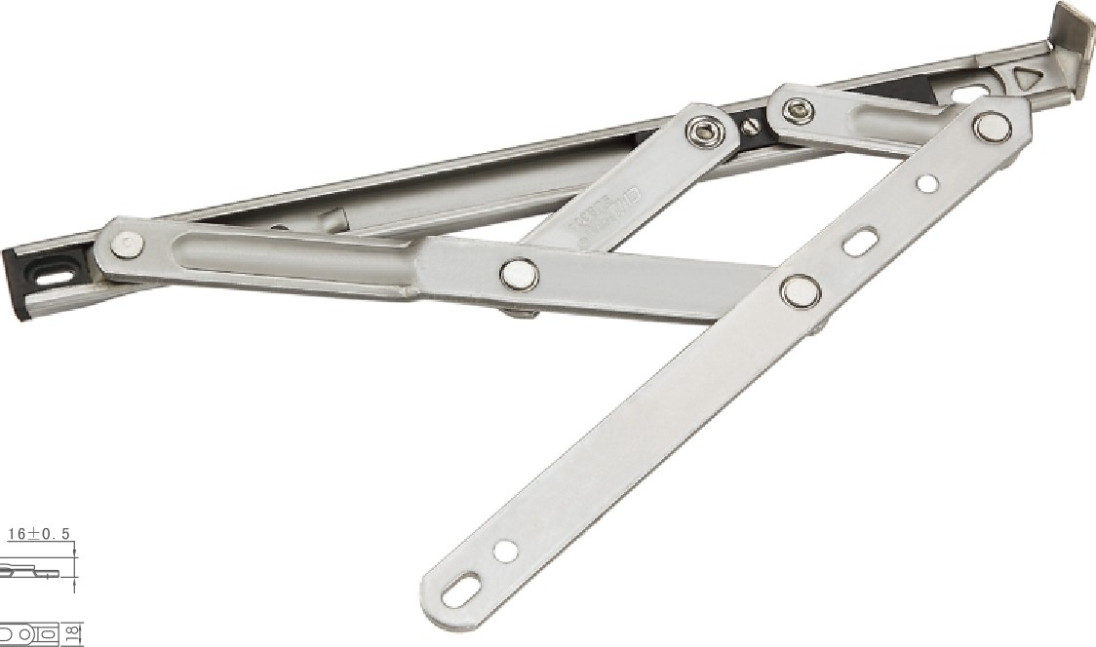

**~~(o~~** ~~@ o~~ **~~o~~** 0 0

|  |  |  |  |
| --- | --- | --- | --- |
| .□, |  | *I -*  \ - | |
|  | | |  |

|  |  |  |  |  |  |
| --- | --- | --- | --- | --- | --- |
| �R M | **WIDTH**  **(mm)** | **HEIGHT**  **(mm)** | **BEARING**  (Kg) | **OPENING ANGLE** | **MEMBER NUMBER** |
| **CGHC001-18-10"** | 400 | **1200** | 18 | 90" | 4 |
| **CGHC**□**Dl-18-12"** | 500 | **1200** | 22 | **45/90°** | 4 |
| **CGHC00l-18-14"** | 600 | **1500** | 26 | **45/90°** | 4 |
| **CGHC**□**Dl-18-16"** | 650 | **1500** | 28 | **45/90°** | 4 |
| **CGHC00l-18-18"** | 700 | **1500** | 30 | **45/90°** | 4 |

|  |  |
| --- | --- |
| ITEM NO. | CGHC001-18 |
| MATERIAL | STAINLESS STEEL |
| PACKAGING | 60 PCS/CTN |

|  |  |  |  |
| --- | --- | --- | --- |
| .□, |  | '��  1 7 | |
|  | | |  |

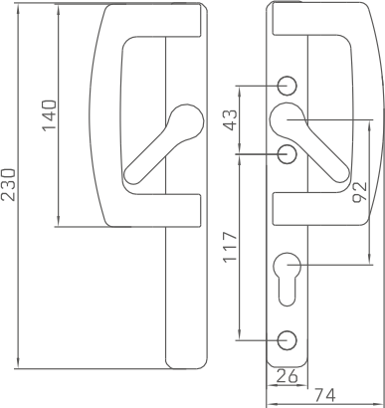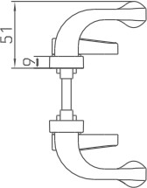0 0 o **O** @) 0 0) > ollg] "'(

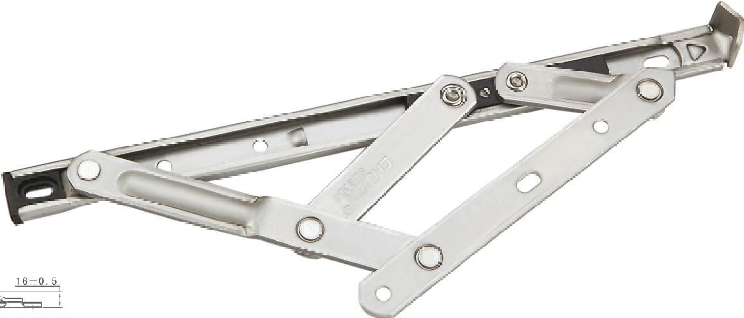

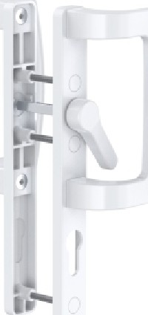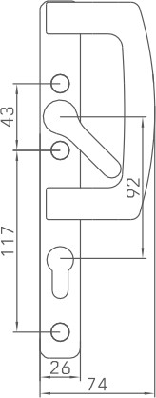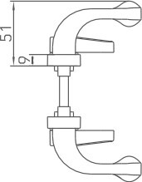

|  |  |  |  |  |
| --- | --- | --- | --- | --- |
| .□, | *I ��* | | | |
|  | \ | �'---, | |
|  | | | |  |

|  |  |  |  |  |  |
| --- | --- | --- | --- | --- | --- |
| **l R**  M | **WIDTH**  **(mm)** | **HEIGHT**  **{mm)** | **BEARING**  (Kg) | **OPENING**  **ANGLE** | **MEMBER NUMBER** |
| **CGHC002-18-10'** | **1100** | 600 | 25 | 40· | 4 |
| **CGHC002-18-12"** | **1200** | 750 | 28 | ***30135°*** | 4 |
| **CGHC002-18-14'** | **1300** | 900 | 33 | **30/35°** | 4 |
| **CGHC002-18-16"** | **1400** | **1000** | 38 | **25/30°** | 5 |
| **CGHC002-18-18'** | **1400** | **1100** | 42 | **25/30°** | 6 |
| **CGHC002-18-20"** | **1500** | **1200** | 45 | **25/30°** | 6 |

|  |  |
| --- | --- |
| ITEM NO. | CGHC002-18 |
| MATERIAL | STAINLESS STEEL |
| PACKAGING | 60 PCS/CTN |

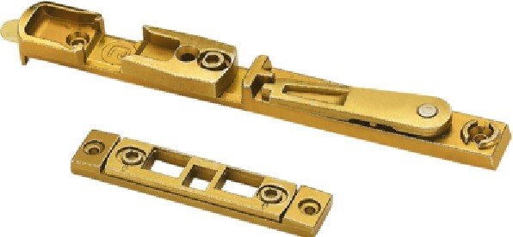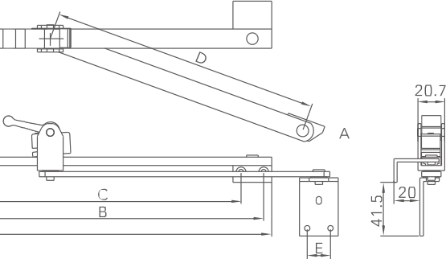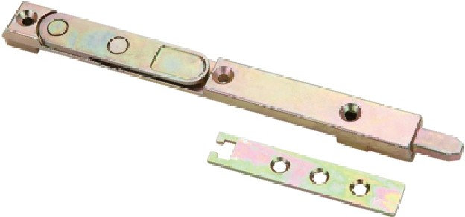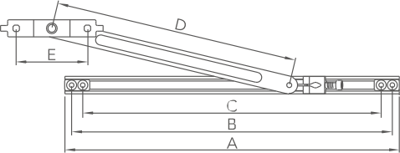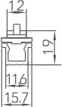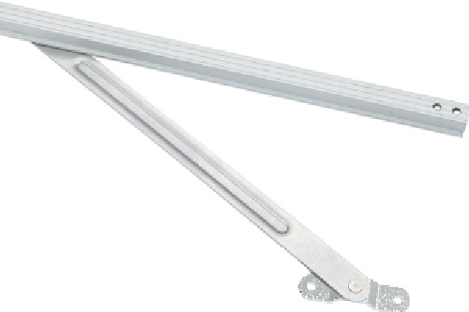

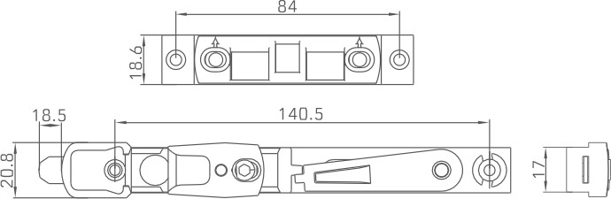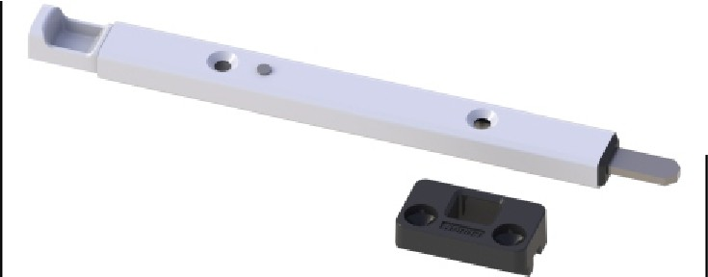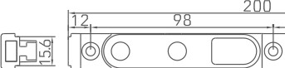

□��Jl =®=o==A===@== = ·=

3 4

5==i--1'LLi I

1® ?1 1

r

,;=·J[

ALUMINUM&ZINC

-+-1-00_P_C_S_/C_T_N

MATERIAL

t-P_A_C_K_A_G_I_N_G

CGCX025

ITEM NO.

100 PCS/CTN

PACKAGING

ZINC

MATERIAL

611

CGCX016

ITEM NO.

100 PCS/CTN

PACKAGING

CARBON STEEL

MATERIAL

�

'----------'-'-T------>+---+-½J-�

�181 � D�D

CGCX004

ITEM NO.

100 PCS/CTN

PACKAGING

ZINC

MATERIAL

;§©ij IIll§: *§* □)(®11;1 @

141

8.5

8 @

CGCX003B

ITEM NO.

100 PCS/CTN

PACKAGING

ZINC

MATERIAL

CGCX003

ITEM NO.

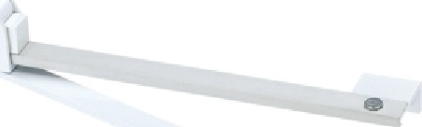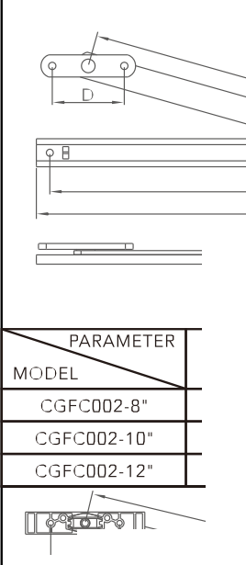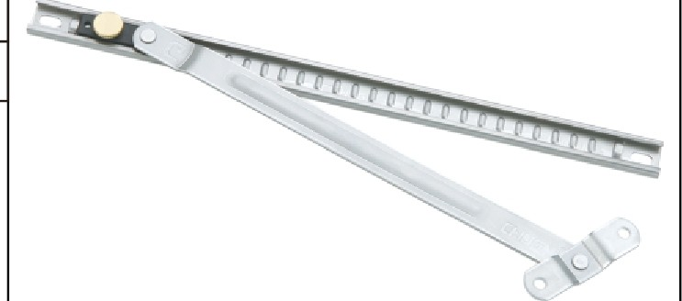

ITEM NO.

CGFC001

MATERIAL

ALUMINUM

PACKAGING

100 PCS/CTN

...

ITEM NO.

CGFC002

�

MATERIAL

ALUMINUM

PACKAGING 200 PCS/CTN

8

A

�

A

D

WIDTH OPENING

C

210 191 138 49

250 231 164 49

300 281 218 49

(min) ANGLE

270 77'

320 90°

415 90°

*D*

_E_

**lmolii1**

1

t

ITEM NO.

CGFC004

MATERIAL

STAINLESS STEEL&ZINC

I

*r*

8

PACKAGING

100 PCS/CTN

ITEM NO.

CGFC004D

MATERIAL

STAINLESS STEEL

PACKAGING 100 PCS/CTN

EYf?M

ITEM NO.

**CGFC008**

I PACKAGING

MATERIAL

STAINLESS STEEL

100 PCS/CTN

- -

-

|  |  |  |  |  |  |
| --- | --- | --- | --- | --- | --- |
| �ER  M | A | 8 | C | D | E |
| CGFC001-10" | 270 | 258 | 223 | 207 | 18 |
| CGFC001-12" | 320 | 308 | 273 | 257 | 18 |

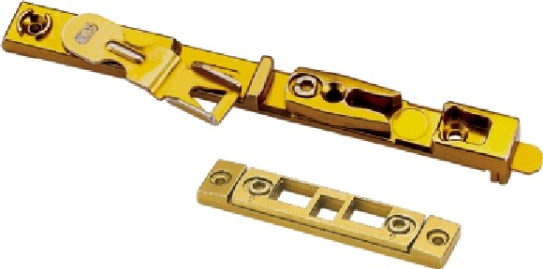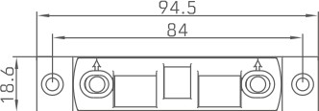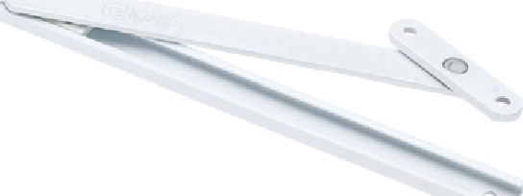

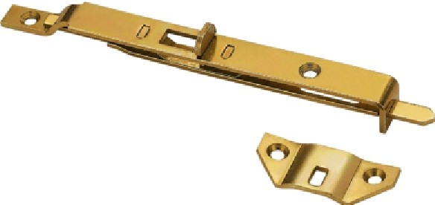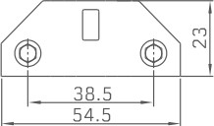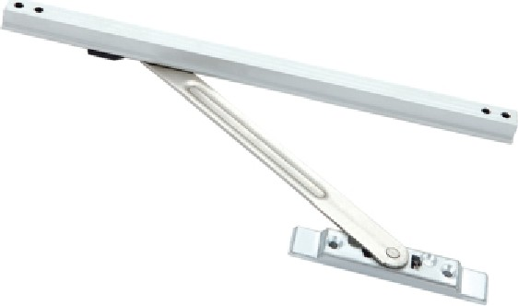

|  |  |  |  |  |  |  |  |
| --- | --- | --- | --- | --- | --- | --- | --- |
| l�R  M | A | 8 | C | D | E | WIDTH  (min) | OPENING  ANGLE |
| CGFC004-8" | 200 | 188 | 168 | 135 | 53 | 300 | 90° |
| CGFC004-1□· | 250 | 238 | 218 | 165 | 53 | 365 | 90° |
| CGFC004-12" | 300 | 288 | 268 | 215 | 53 | 445 | 90° |

|  |  |  |  |  |  |  |  |
| --- | --- | --- | --- | --- | --- | --- | --- |
| �R  M | A | 8 | C | D | E | WIDTH  (min) | OPENING  ANGLE |
| CGFC004D-8" | 200 | 188 | 168 | 135 | so | 300 | 90° |
| CGFC004D-1 0" | 250 | 238 | 218 | 165 | 50 | 365 | 90° |
| CGFCDD4D-12" | 300 | 288 | 268 | 215 | so | 445 | 90° |

|  |  |  |
| --- | --- | --- |
| �ER MODEL | L | A |
| CGCX025-160 | 160 | 72 |
| CGCX025-220 | 220 | 133.5 |
| CGCX025-450 | 450 | 363.5 |

|  |  |  |  |  |  |  |  |
| --- | --- | --- | --- | --- | --- | --- | --- |
| �R  M | A | 8 | C | D | E | WIDTH  (min) | OPENING  ANGLE |
| CGFC00B-8" | 200 | 182 | 173 | 116 | 45 | 240 | 76° |
| CGFC00B-1□· | 250 | 232 | 223 | 166 | 45 | 305 | 90° |
| CGFC00B-12" | 300 | 282 | 273 | 216 | 45 | 405 | 90° |
| CGFC00B-14" | 350 | 333 | 323 | 260 | 45 | 505 | 90° |

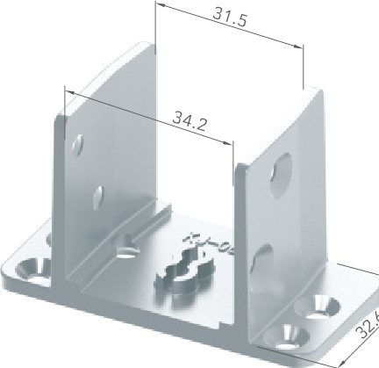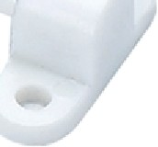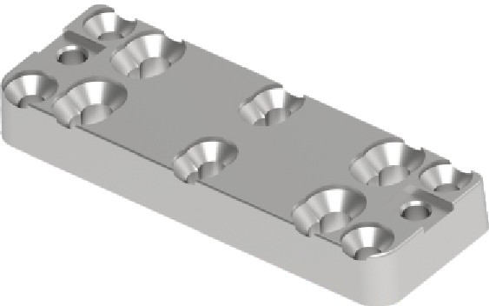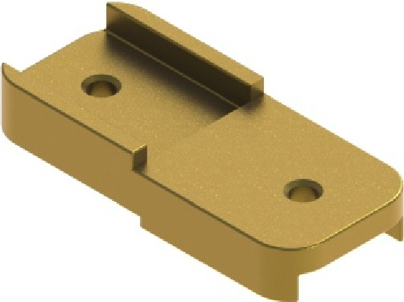

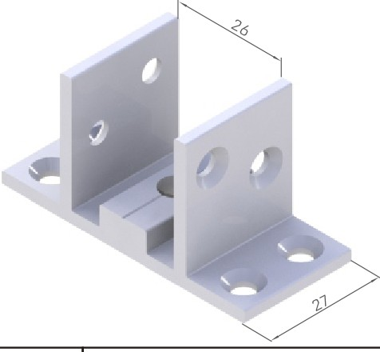

ITEM NO.

CGJM035

ZINC

TEXTURES

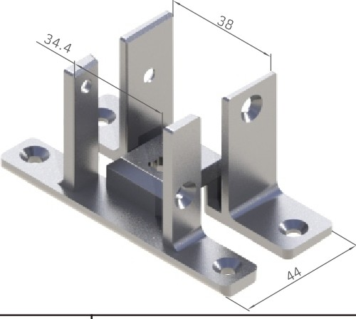

ITEM NO.

CGJM036

ZINC

TEXTURES

|  |  |
| --- | --- |
| ITEM NO. | CGJM017 |
| TEXTURES | ZINC |

|  |  |
| --- | --- |
| ITEM NO. | CGPK012-S |
| TEXTURES | PLASTIC |

|  |  |
| --- | --- |
| ITEM NO. | CGDK01 |
| TEXTURES | ZINC |

|  |  |
| --- | --- |
| ITEM NO. | CGWM01 |
| TEXTURES | ZINC |

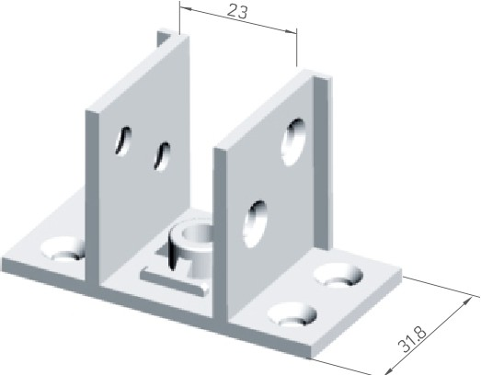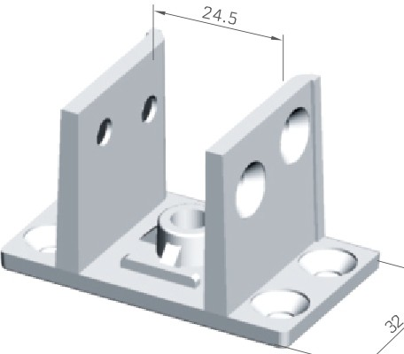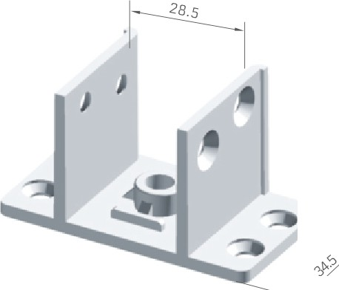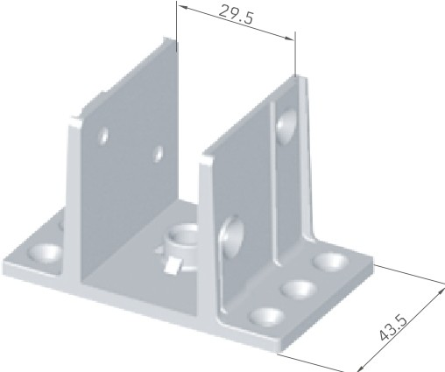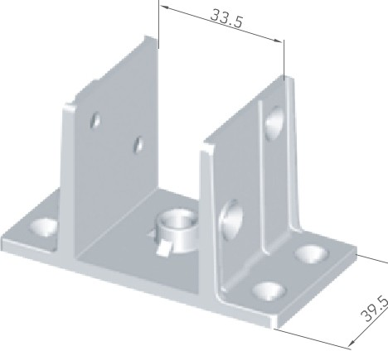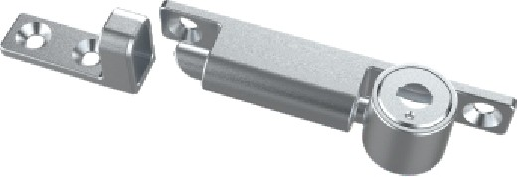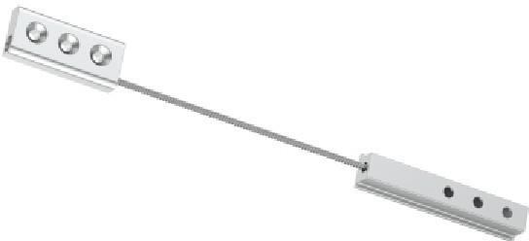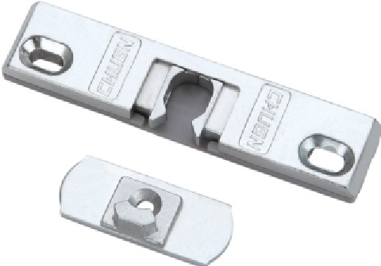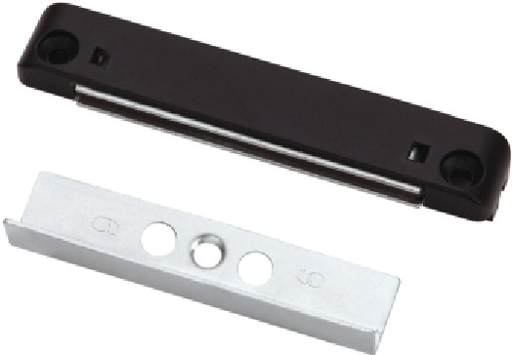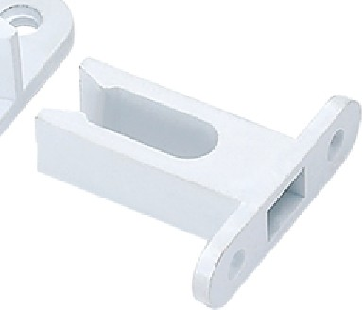,...

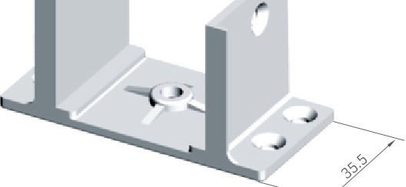

'

|  |  |
| --- | --- |
| ITEM NO. | CGJM010 |
| TEXTURES | ZINC |

|  |  |
| --- | --- |
| ITEM NO. | CGJM011 |
| TEXTURES | ZINC |

|  |  |
| --- | --- |
| ITEM NO. | CGJM012 |
| TEXTURES | ZINC |

|  |  |
| --- | --- |
| ITEM NO. | CGETS02-S |
| TEXTURES | ZINC |

|  |  |
| --- | --- |
| ITEM NO. | CGFZS01-S |
| TEXTURES | ALUMINUM |

|  |  |
| --- | --- |
| ITEM NO. | CGPK001-S(9/13) |
| TEXTURES | ZINC |

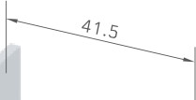

•

|  |  |
| --- | --- |
| ITEM NO. | CGJM013 |
| TEXTURES | ZINC |

|  |  |
| --- | --- |
| ITEM NO. | CGJM014 |
| TEXTURES | ZINC |

|  |  |
| --- | --- |
| ITEM NO. | CGJM016 |
| TEXTURES | ZINC |

|  |  |
| --- | --- |
| ITEM NO. | CGMX01-S(9/13) |
| TEXTURES | PLASTIC&CARBON STEEL |

|  |  |
| --- | --- |
| ITEM NO. | CGJL010C-S |
| TEXTURES | PLASTIC |

|  |  |
| --- | --- |
| ITEM NO. | CGPK011-S |
| TEXTURES | PLASTIC |

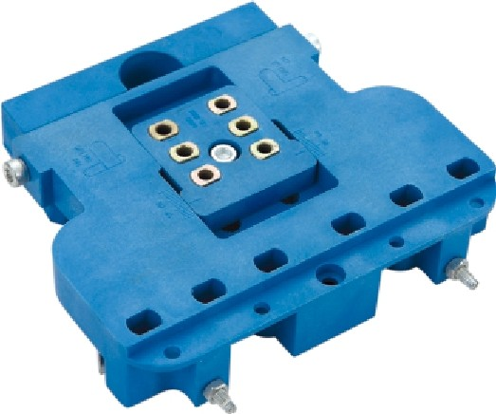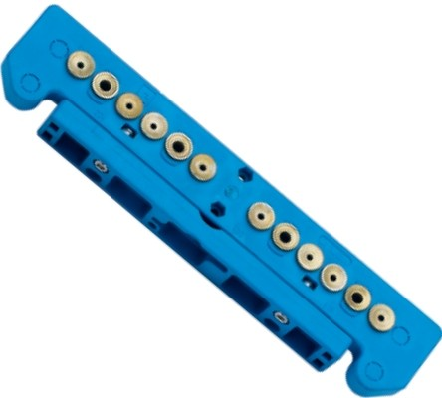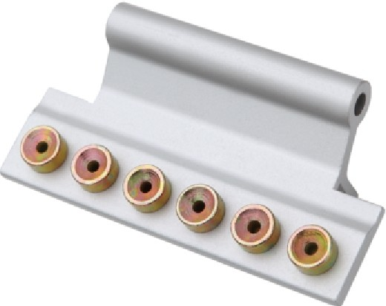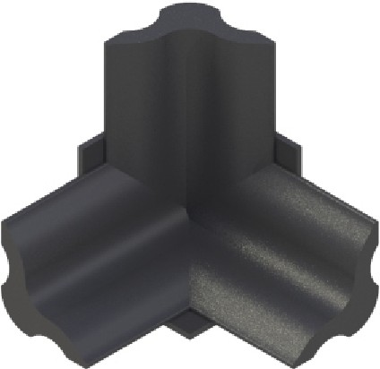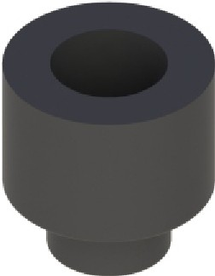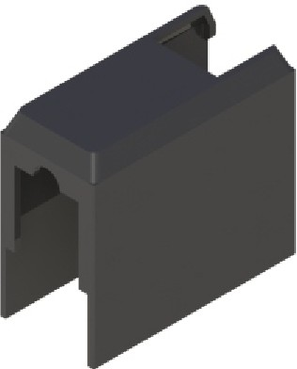

|  |  |
| --- | --- |
| ITEM NO. | CGZM8087-S |
| TEXTURES | PLASTIC |

|  |  |
| --- | --- |
| ITEM NO. | CGZM8088-S |
| TEXTURES | PLASTIC |

|  |  |
| --- | --- |
| ITEM NO. | CGZM8088B-S |
| TEXTURES | ALUMINUM |

|  |  |
| --- | --- |
| ITEM NO. | CGWM07 |
| TEXTURES | PLASTIC |

|  |  |
| --- | --- |
| ITEM NO. | CGWM08 |
| TEXTURES | RUBBER |

|  |  |
| --- | --- |
| ITEM NO. | CGWM09 |
| TEXTURES | PLASTIC |

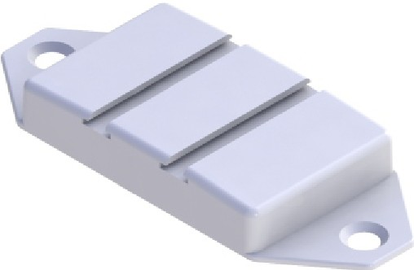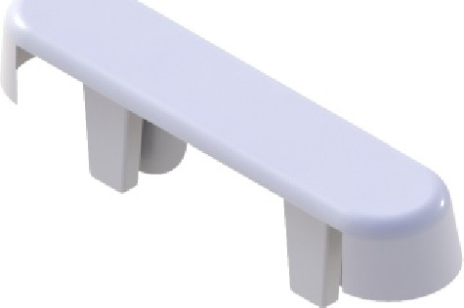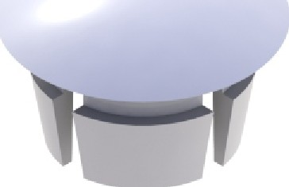

|  |  |
| --- | --- |
| ITEM NO. | CGWM10 |
| TEXTURES | PLASTIC |

|  |  |
| --- | --- |
| ITEM NO. | CGWM11 |
| TEXTURES | PLASTIC |

|  |  |
| --- | --- |
| ITEM NO. | CGWM12 |
| TEXTURES | PLASTIC |

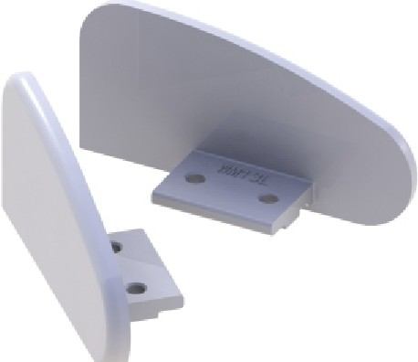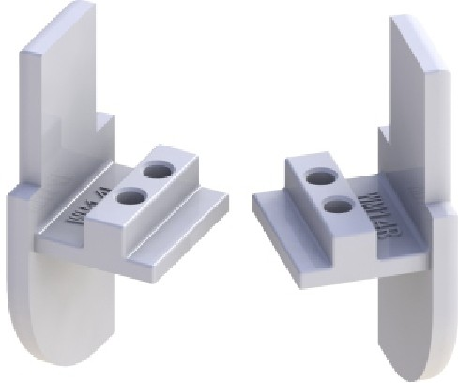

|  |  |
| --- | --- |
| ITEM NO. | CGWM13 |
| TEXTURES | ZINC |

|  |  |
| --- | --- |
| ITEM NO. | CGWM14 |
| TEXTURES | ZINC |